Lab Report

**Lab 04: Configuring Windows Services**

**Subject:** Quản trị mạng và hệ thống

**Class:** NT132.N21.1

**Group Members (Group 02):**

|  |  |  |
| --- | --- | --- |
|  | **Students’s names** | **Student ID** |
| 1 | Nguyễn Trần Bảo Quốc | 21520421 |
| 2 | Nguyễn Trọng Tấn Phong | 21522460 |
| 3 | Nguyễn Thành Đăng | 21520683 |
| 4 | Trịnh Tấn Đạt | 21520714 |

|  |
| --- |
| **Self-evaluated Score** |
| **9** |

**Evaluation:**

|  |  |
| --- | --- |
| Total time spent | 7 days |
| Lab Task | • Task 1, 2: Quốc  • Task 3: Phong  • Task 4: Đạt  • Task 5: Đăng  • Report Writing: Đăng |
| Issues *(if any)*  + Difficulty  + Recommendations |  |

Table of Contents

A. Lab Tasks 4

1. Kick-off 4

2. DNS Service 4

3. DHCP Service 20

4. Web Service (IIS) and FTP server 28

5. Mail Server 40

B. References 50

# Lab Tasks

## Kick-off

### Why do we need DNS, DHCP, FTP and Mail service? Is the networking system working correctly without these services?

A Domain Name System (DNS) translates human-readable domain names (such as google.com) into IP addresses which can be used by browsers to get to websites and other Internet resources. Thanks to DNS, people can simply enter the website’s name, instead of memorizing a long list of IP addresses.

Dynamic Host Configuration Protocol (DHCP) is a network protocol used to automate the process of configuring devices in a network. DHCP provides its clients with IP addresses, subnet masks and default gateway.

File Transfer Protocol (FTP) is a standard network protocol that enables computers to transfer files over the internet. FTP provides a reliable way to transfer files over the internet, while maintaining the integrity of the data being sent.

Mail services, such as emails, are essential for any Internet user. They allow fast and efficient communication across the world which is important in both personal and business settings. People send out millions of newsletters, marketing materials and notifications using emails every day.

DNS, DHCP, FTP and mail services are indispensable for the networking system. DNS makes it easier for users to access websites. DHCP minimizes errors caused by manual IP address configuration and reduce the burden of network administrators. Without FTP, transferring large files between computers can be difficult or even impossible. Finally, mail services like emails offers a fast, affordable and efficient way to communicate and transfer information across the world.

## DNS Service

### Assign the corresponding IP address for the network interface (refer to Table 1)

**Step1**: Start -> Control Panel -> Network and Internet -> Network and Sharing Center -> Ethernet.

**Step2**: Properties -> Choose “Internet Protocol Version 4 (TCP/IPv4)” -> Properties.

**Step3**: Fill in the parameters like the picture below.

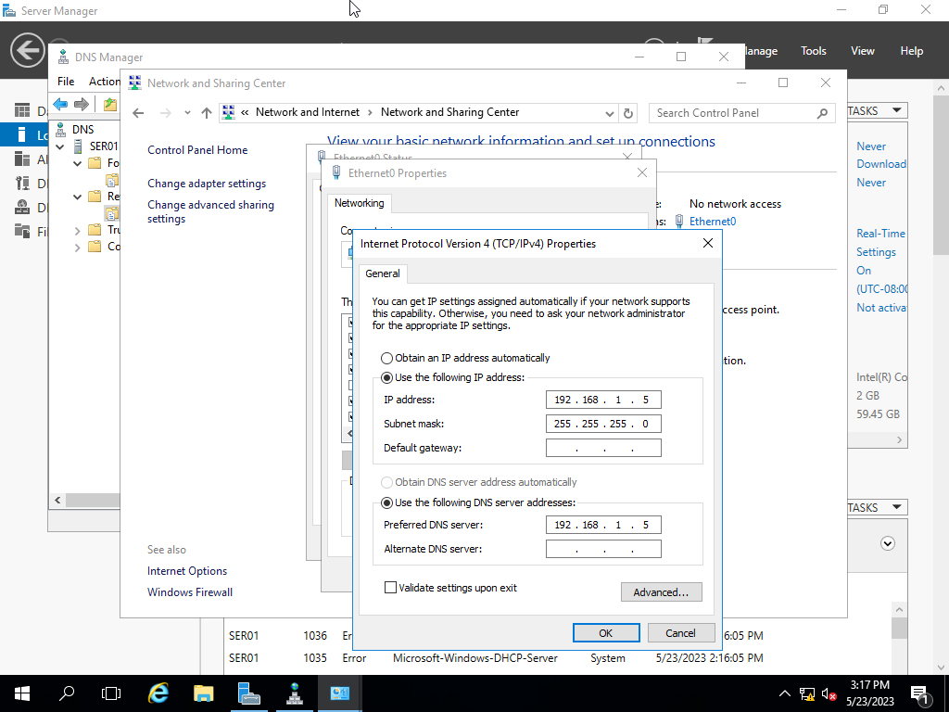

### Change the Primary DNS Suffix to groupX.local (X is your group ID), and the Computer Name to ser01

**Step1**: Start -> Control panel -> System and Security -> System.

**Step2**: Advanded system setting -> Choose tab “Computer name” -> Change.

**Step3**: Fill in the parameters like the picture below.

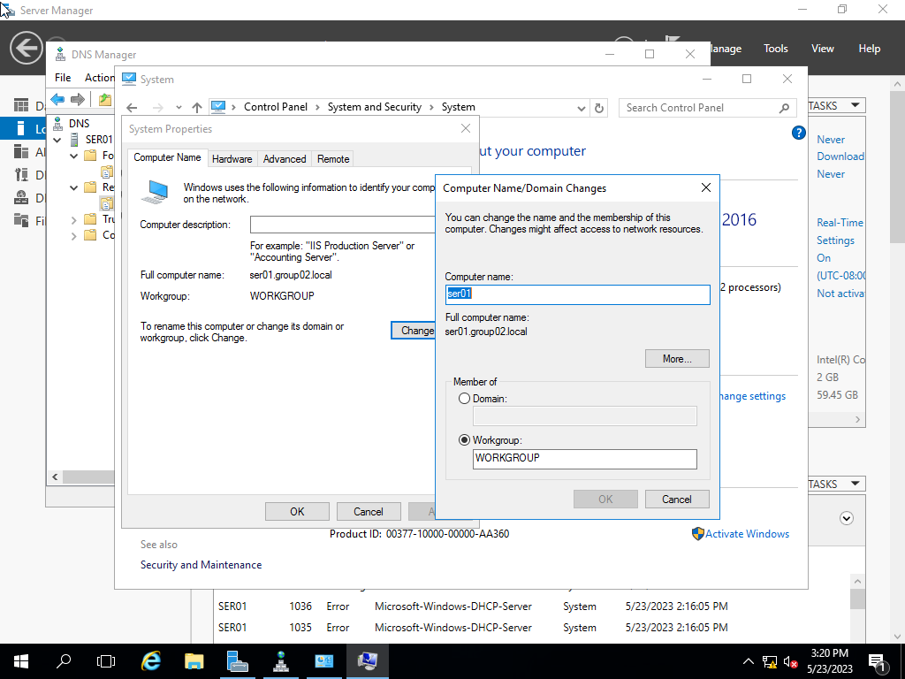

### Install and configure the DNS service. Configure the Primary Zone groupX.local on the Forward Lookup Zone and Reverse Lookup Zone.

**Step1**: Server Manager -> Manage -> Add Roles and Features -> Next -> Next.

**Step2**: Choose DNS Server in “Server Roles” -> Add Features -> Next -> Next -> Install -> Close.

**Step3**: Tool -> DNS.

**Step4**: In “SER01” -> Right click “Forward lookup Zone” -> New Zone..

**Step5**: Primary zone -> set name -> Next -> Do not dynamic updates -> Next -> Finish.

**Step6**: Right click “Reverse Lookup Zones” -> choose “IPv4 Reverse Lookup Zone” -> Next -> set IP address -> Next -> Finish.

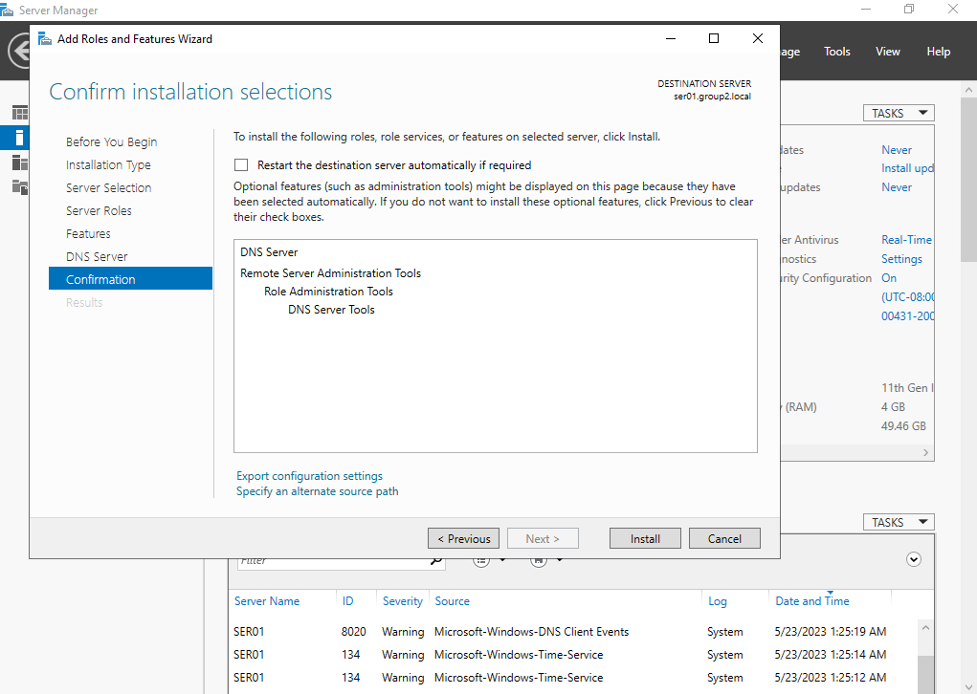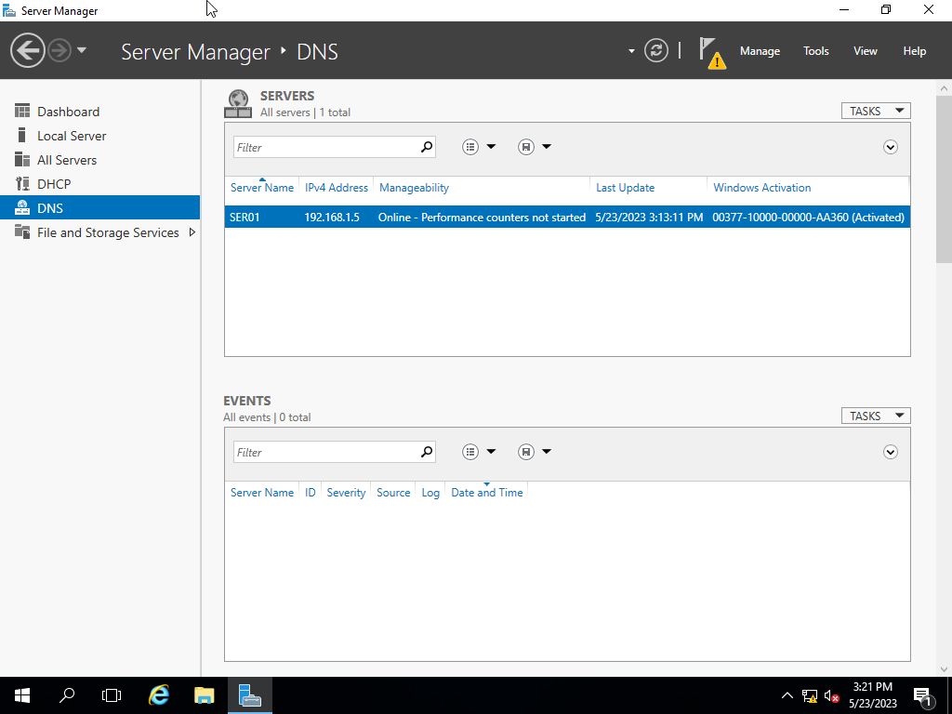

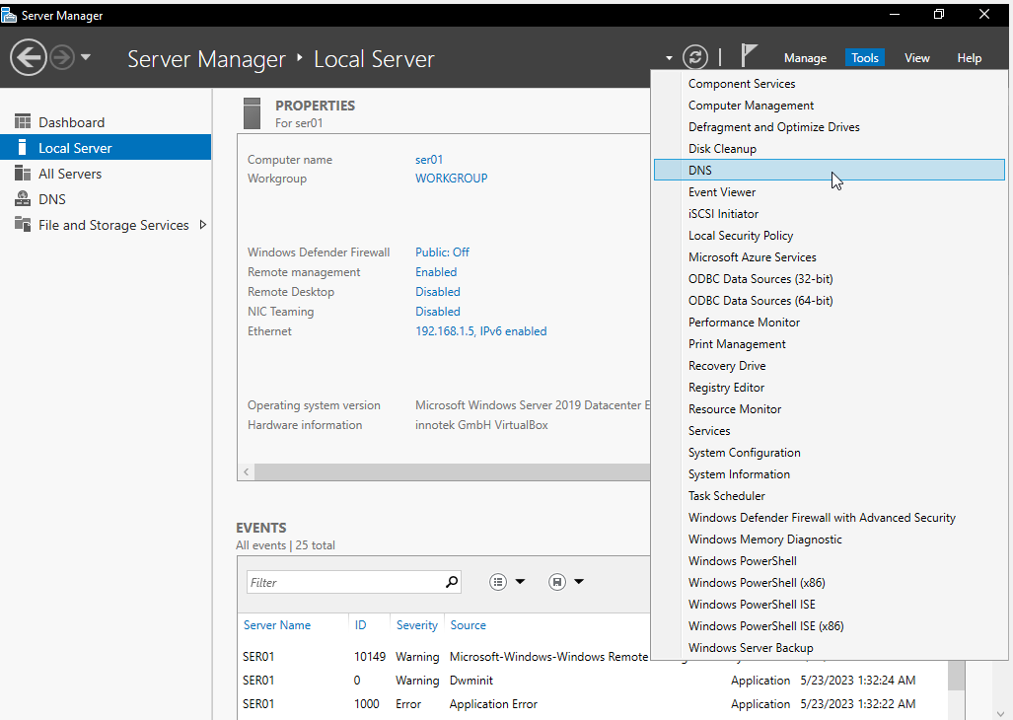

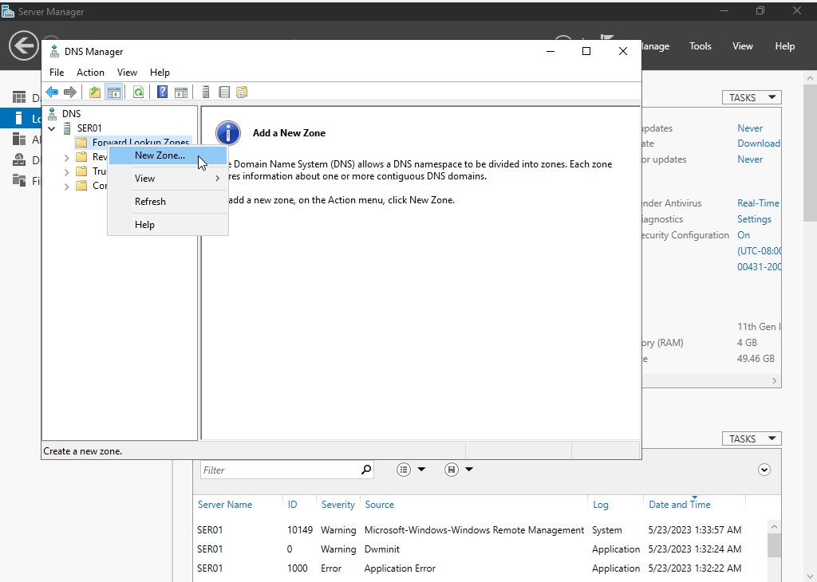

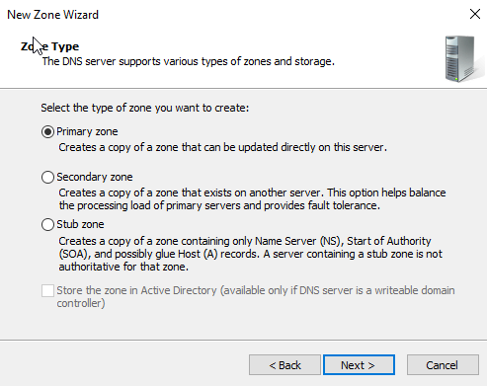

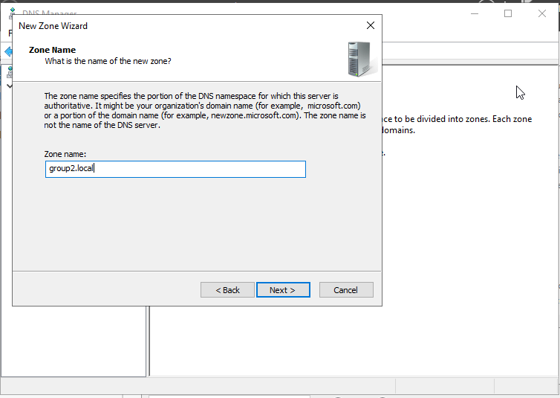

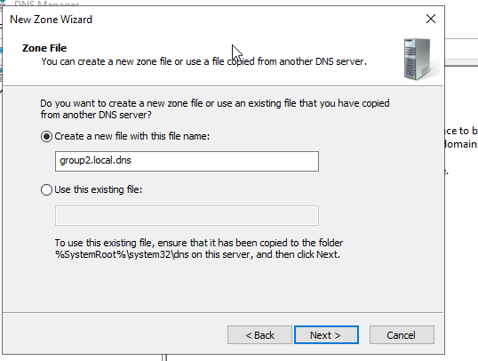

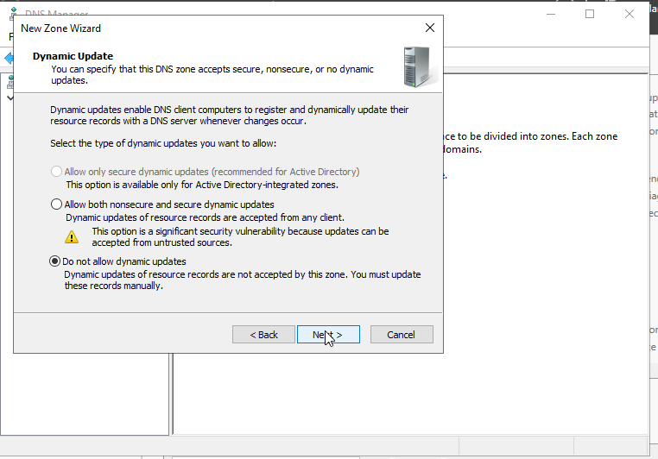

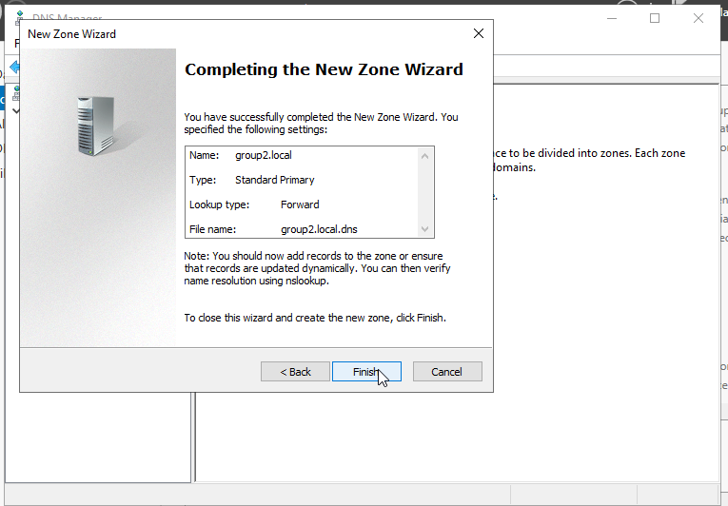 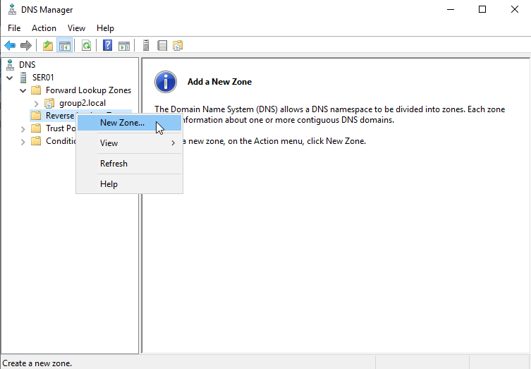

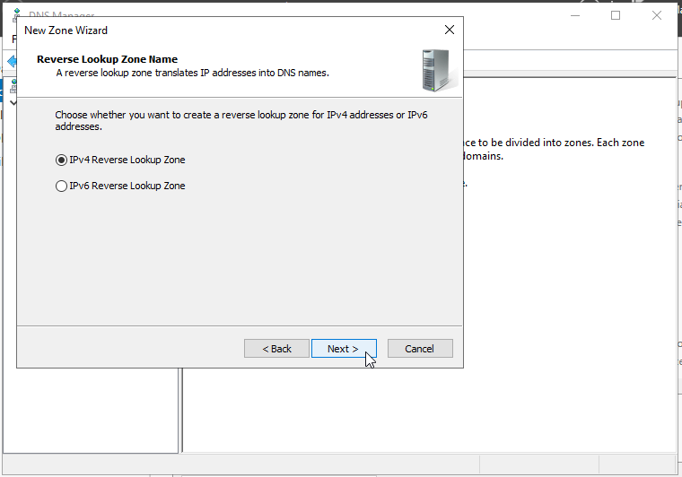

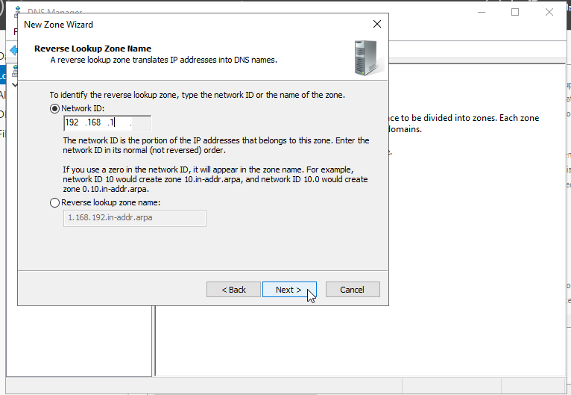 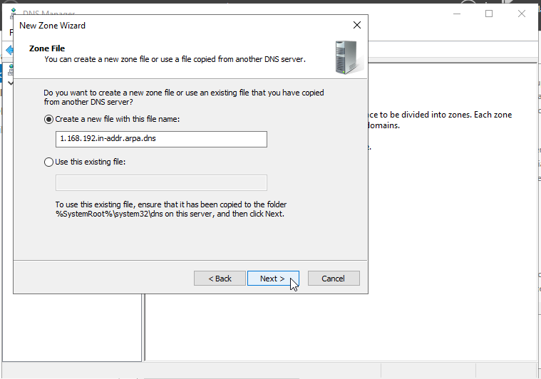

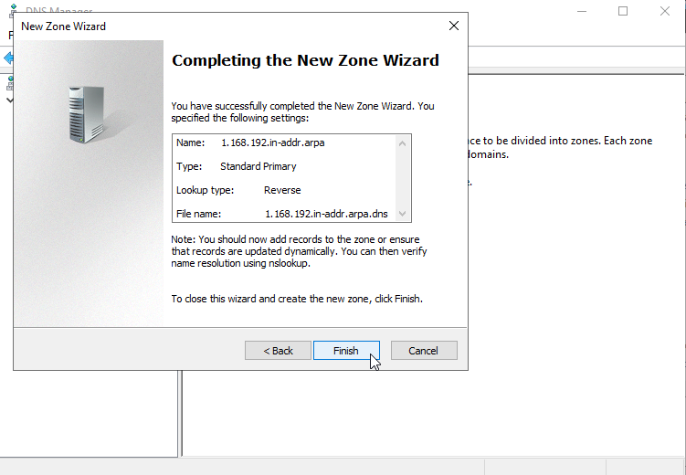



### Create DNS records on both Forward Lookup Zone and Reverse Lookup Zone for hosts below

* + ser01.groupX.local → 192.168.1.5
  + dns.groupX.local → ser01.groupX.local
  + groupX.local → 192.168.1.5
  + mmt.groupX.local → dns.groupX.local

**Step1**: Server Manager -> Tool -> DNS.

**Step2**: In node “Forward lookup Zones” choose “group02.local.

**Step3**: Fill in the parameters like the picture below.

* DNS and MMT choose “CNAME”

* 192.168.1.5 choose “New Host”

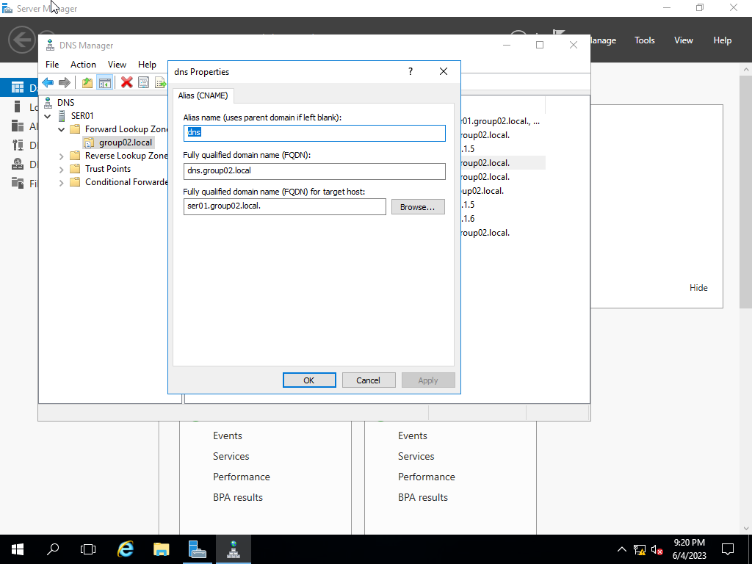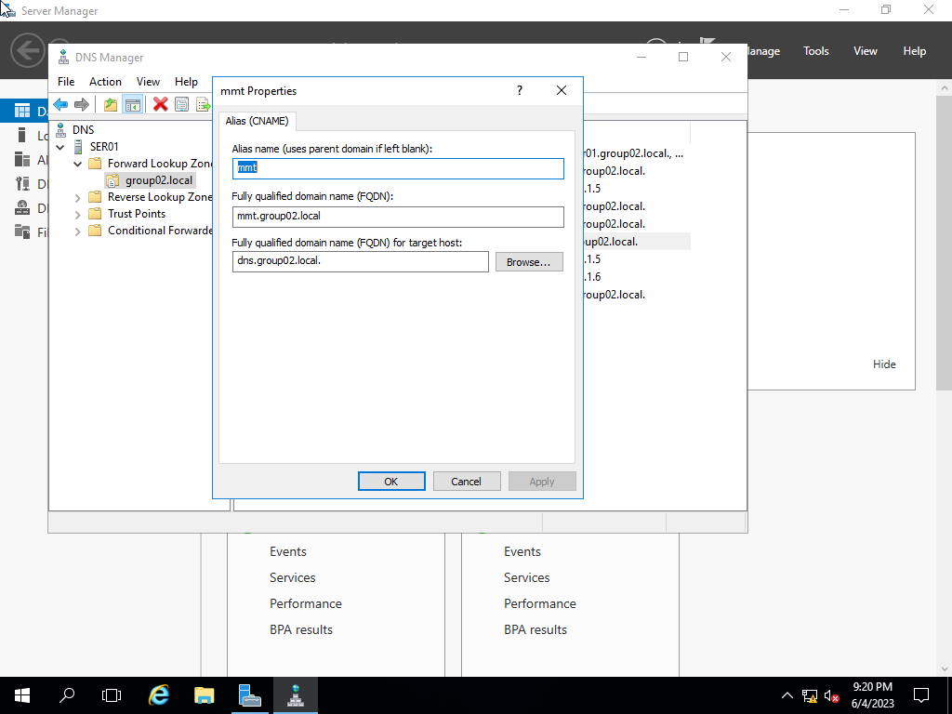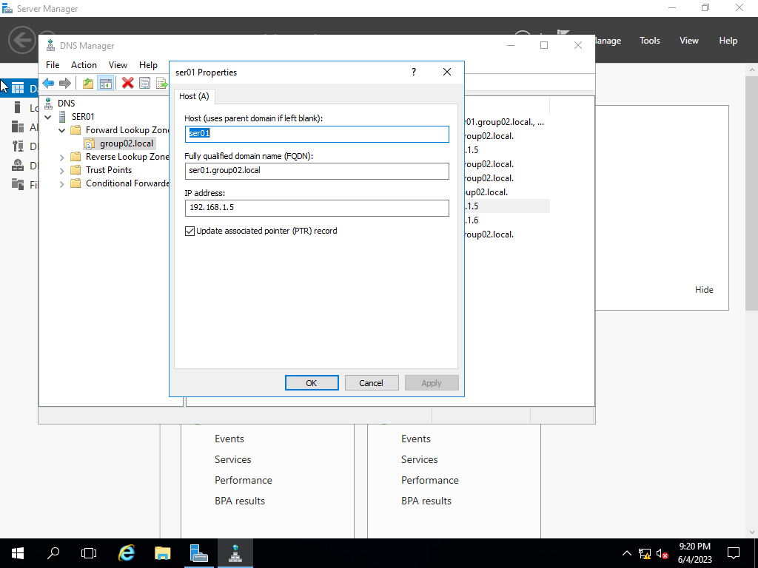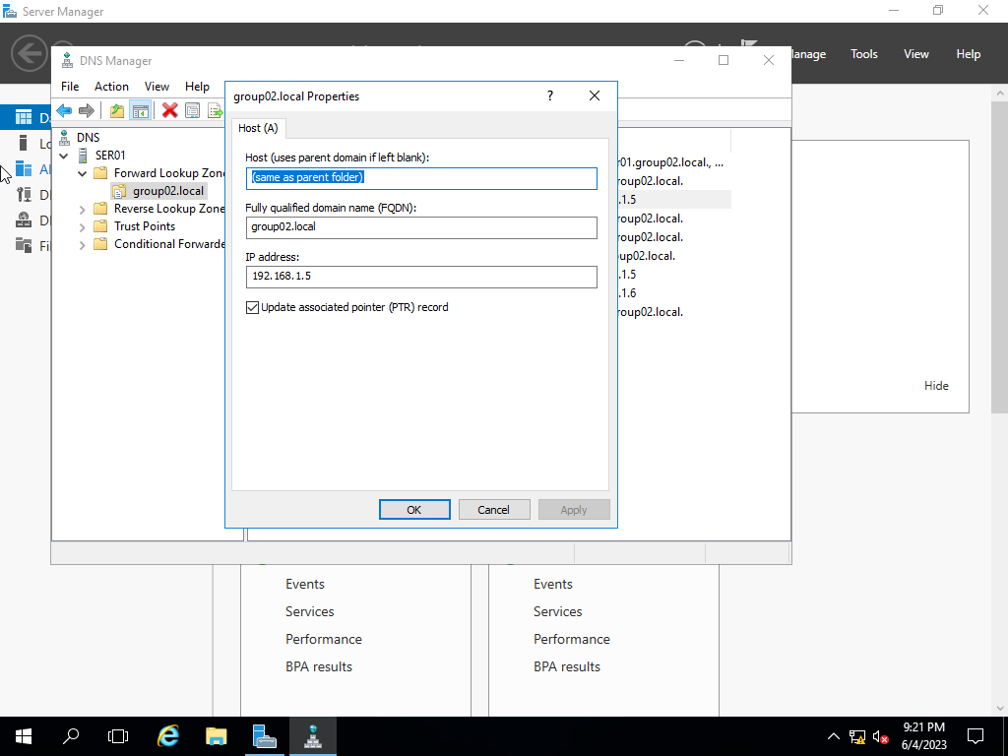

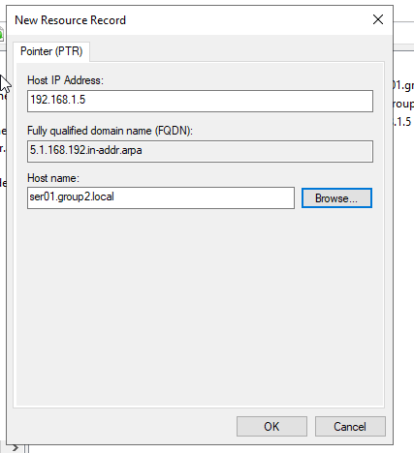

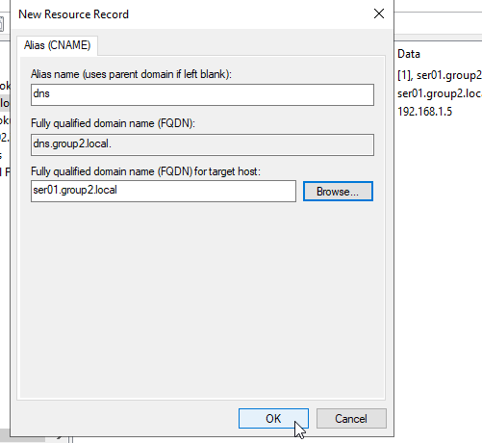

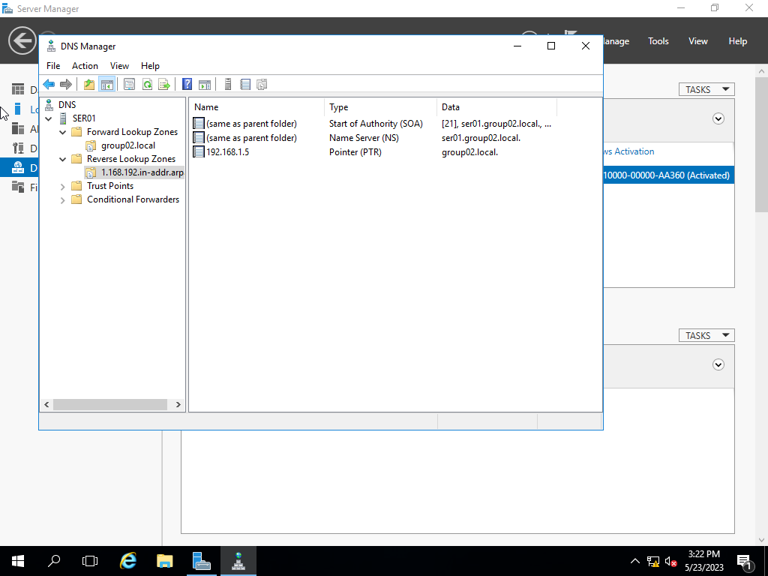



### Assign the corresponding IP address for the network interface (refer to Table 1). Then use the nslookup command to retrieve the DNS information (you need briefly explain the result in your report)

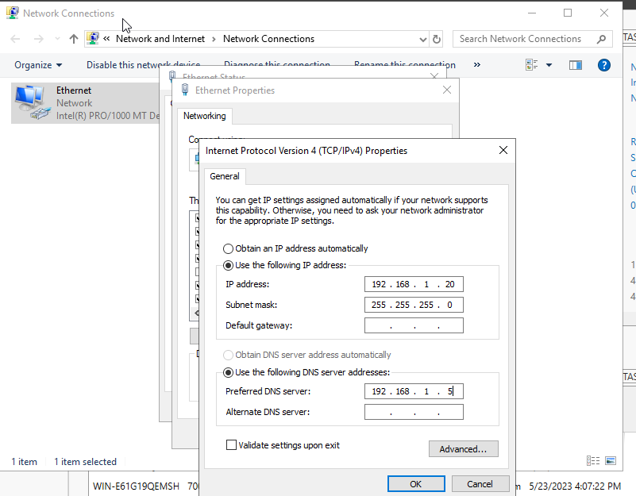

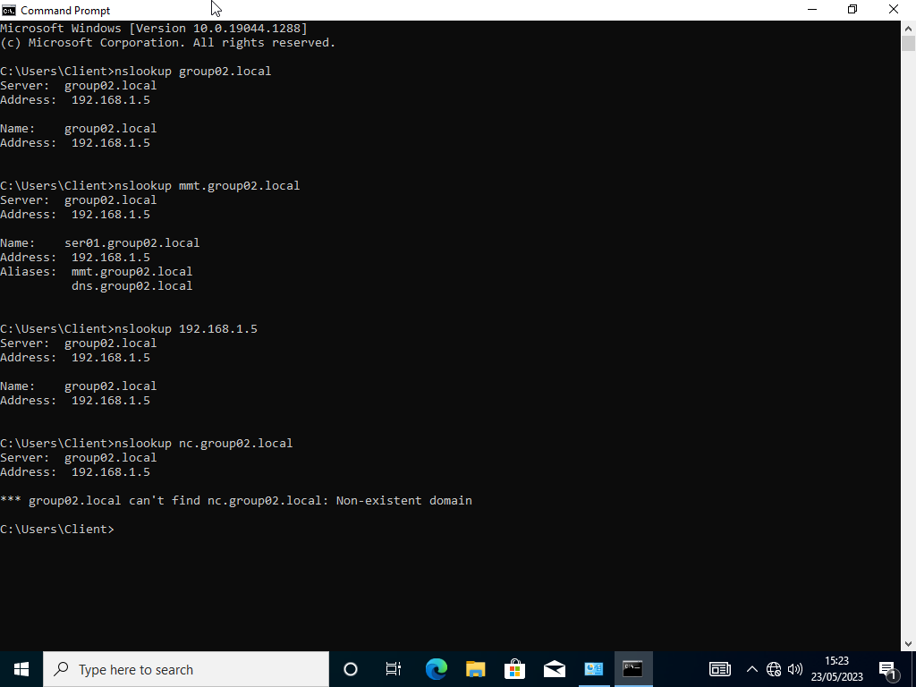

## DHCP Service

### Add the “DHCP” feature.

**Step1**: Server Manager -> Add features Wizard -> Next -> Next.

**Step2**: Choose DHCP Server in “Server Roles” -> Add features -> Next -> Next -> Close.

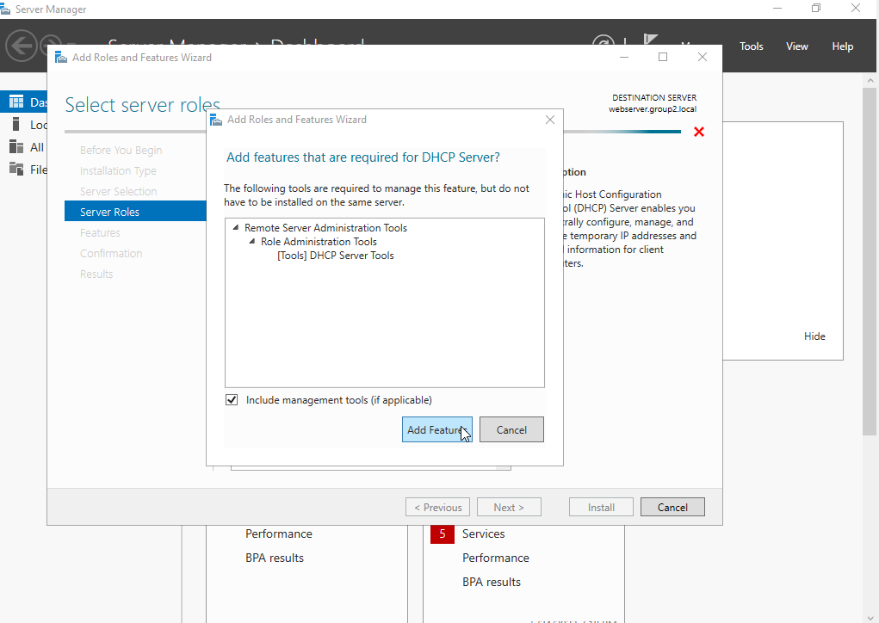

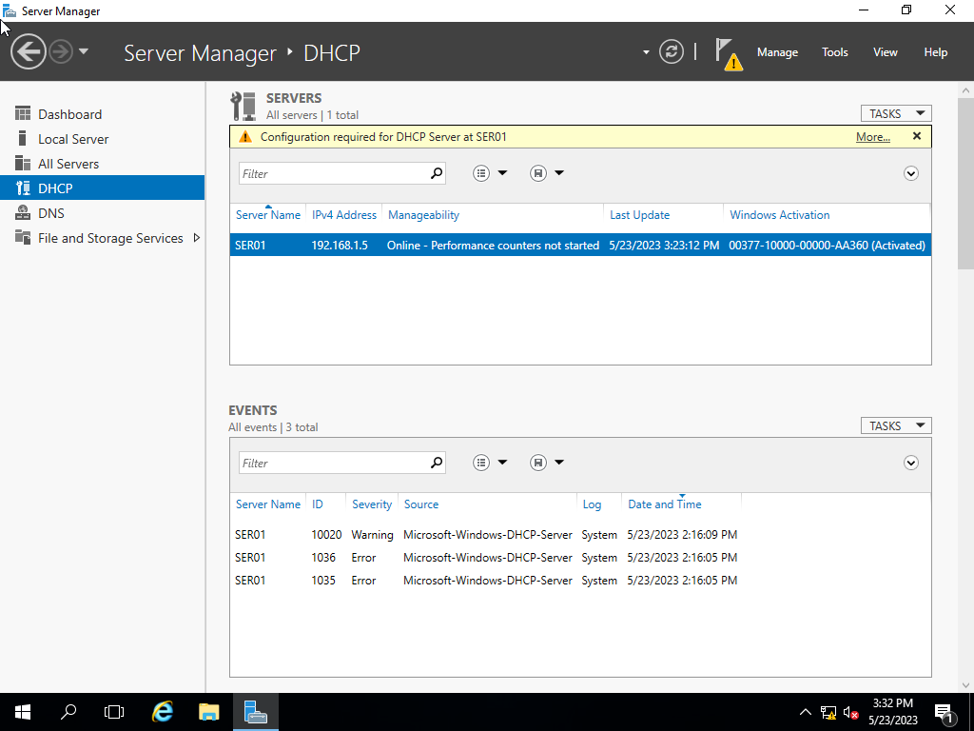

### Create a new "DHCP scope" if it does not exist. Then configure this scope with the following information:

IPs pool: 192.168.1.100 à 192.168.1.200

Subnet mask: 255.255.255.0

**Step1**: Server Manager -> Tool -> DHCP Manager.

**Step2**: Choose node “DHCP” -> webserver -> IPv4.

**Step3**: Right click -> New scope -> Fill IP start and end -> Next -> Next -> Next -> Next -> Next -> Finish.

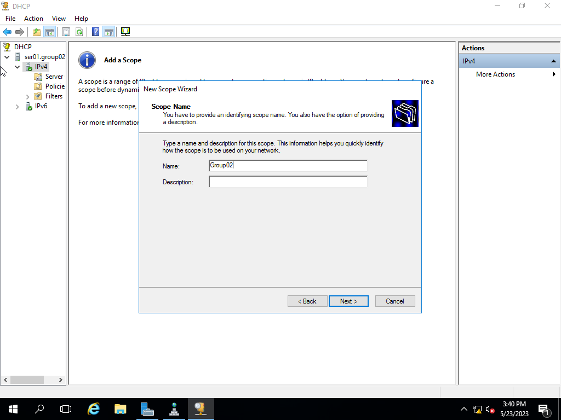

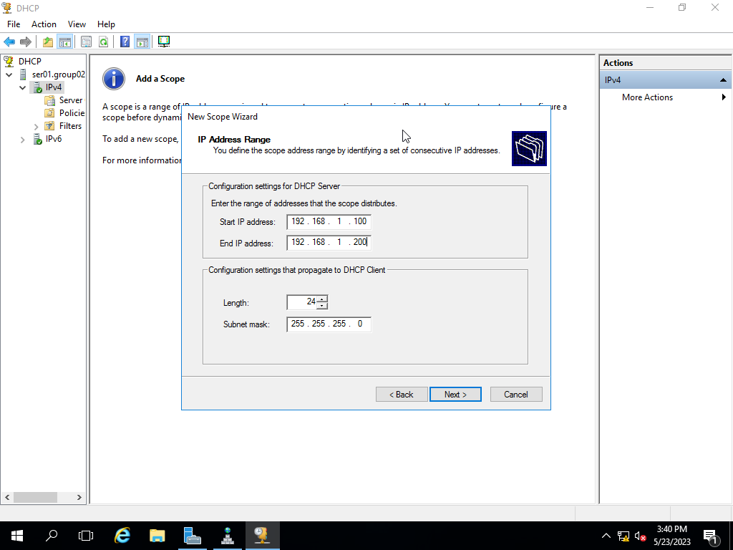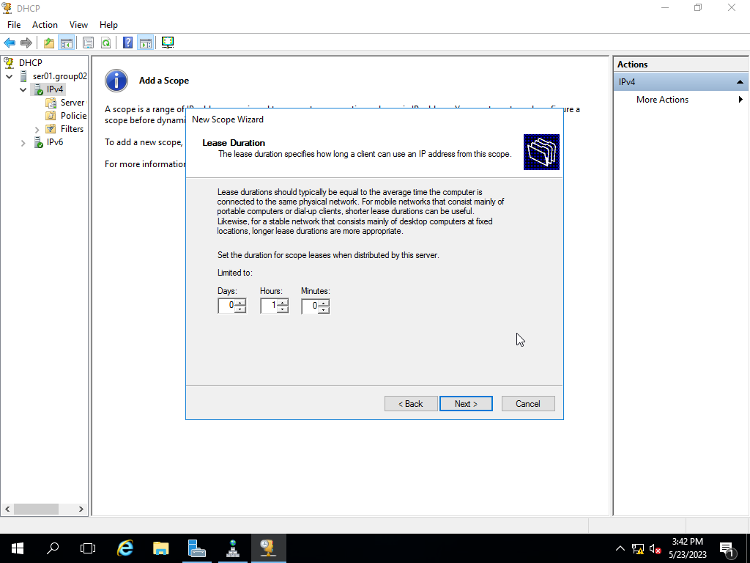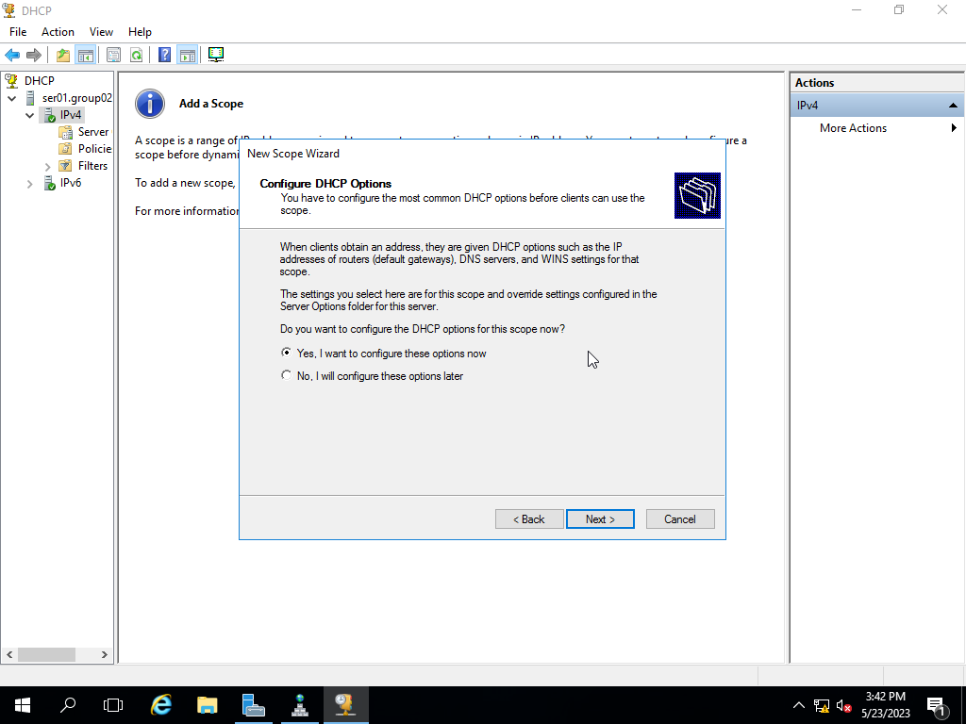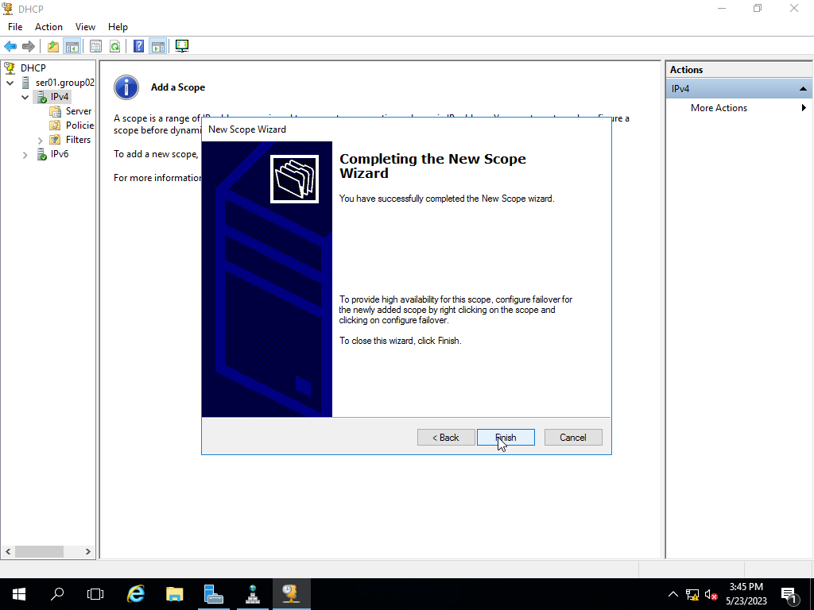

### Configure the DHCP server so that client will receive the information of the Default Gateway and DNS server when the client obtains a new IP address.

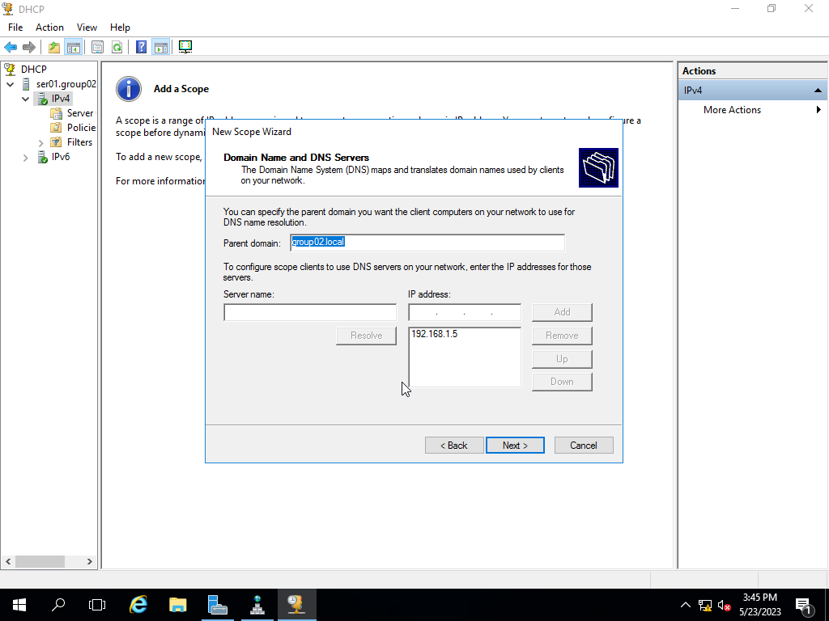



### Exclude the IP between 192.168.1.180 and 192.168.1.190 from being leased.

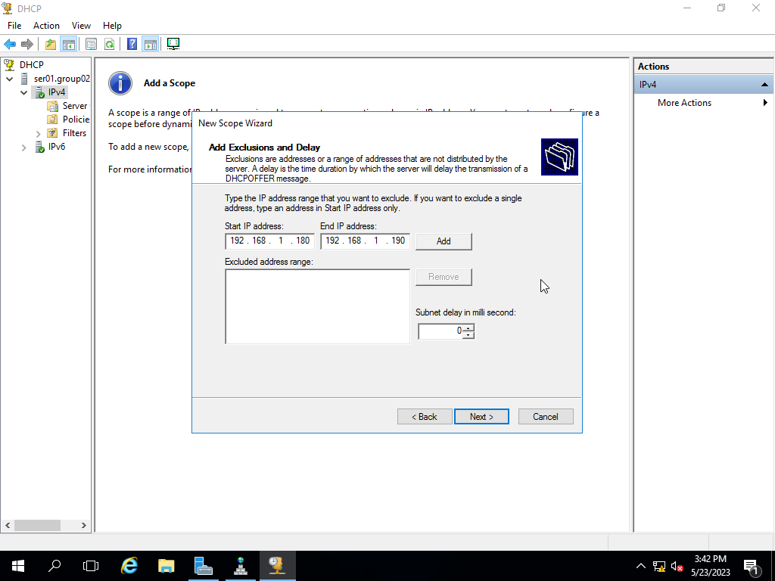 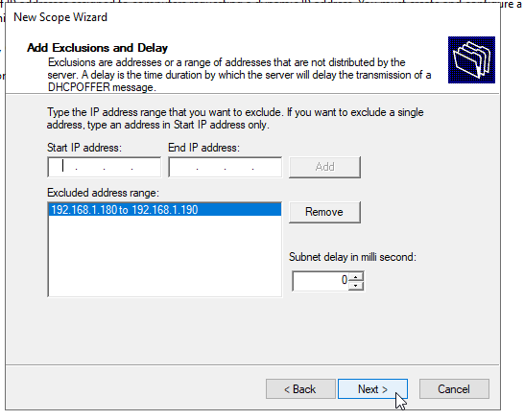

### Configure the Client that automatically obtains a new IP address and relevant information (such as Default Gateway, DNS server,...) when joining to the net.

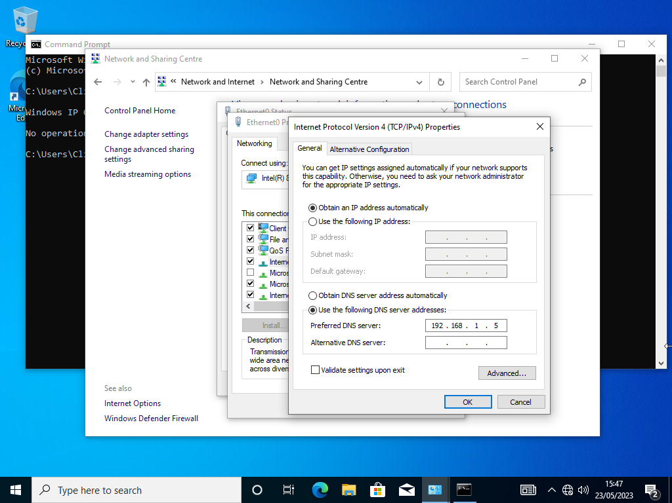

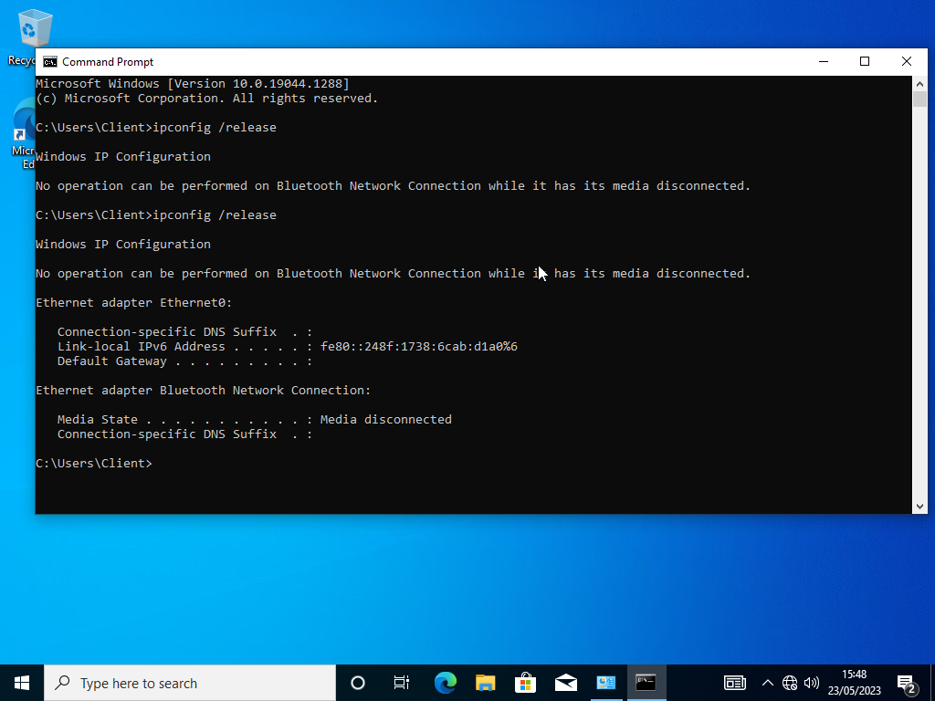

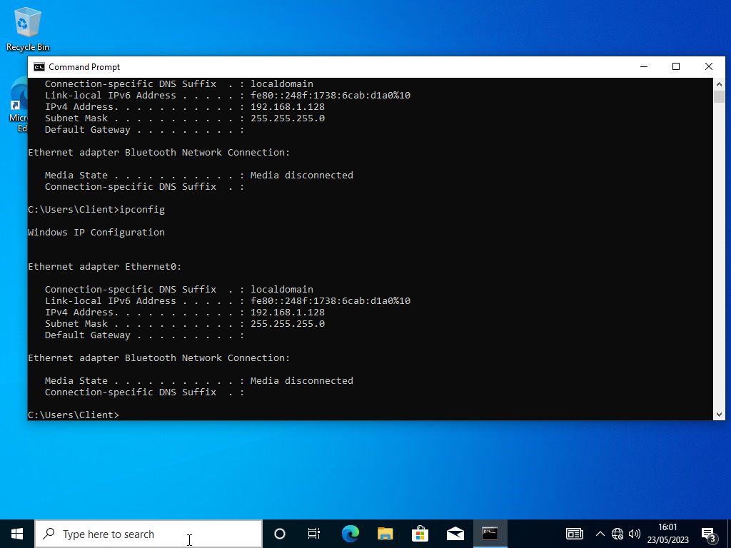

## Web Service (IIS) and FTP server

### Create new DNS records for all hostnames below:

ser02.groupX.local -> 192.168.1.6

www.groupX.local -> ser02.groupX.local

ftp.groupX.local -> ser02.groupX.local

**Step1**: Server Manager -> Tool -> DNS.

**Step2**: In node “Forward lookup Zones” choose “group02.local.

**Step3**: Fill in the parameters like the picture below.

* FTP and WWW choose “CNAME”

* 192.168.1.6 choose “New Host”

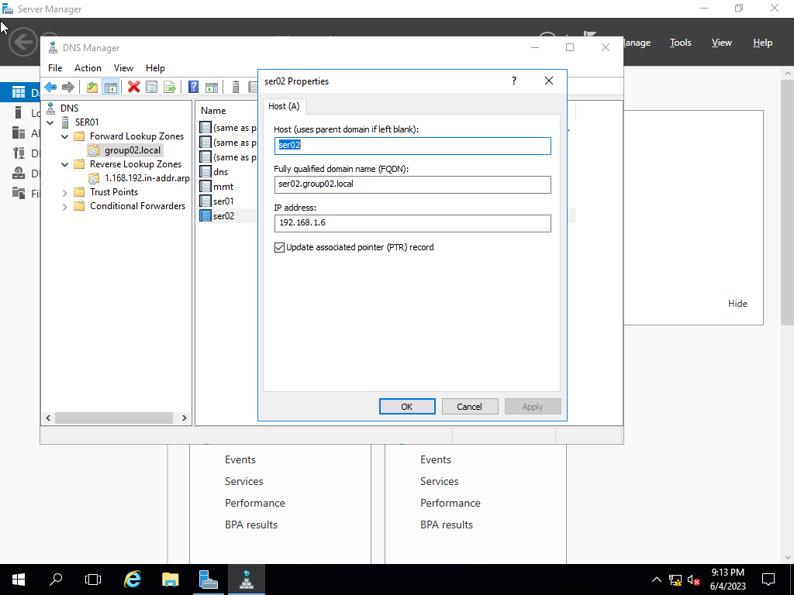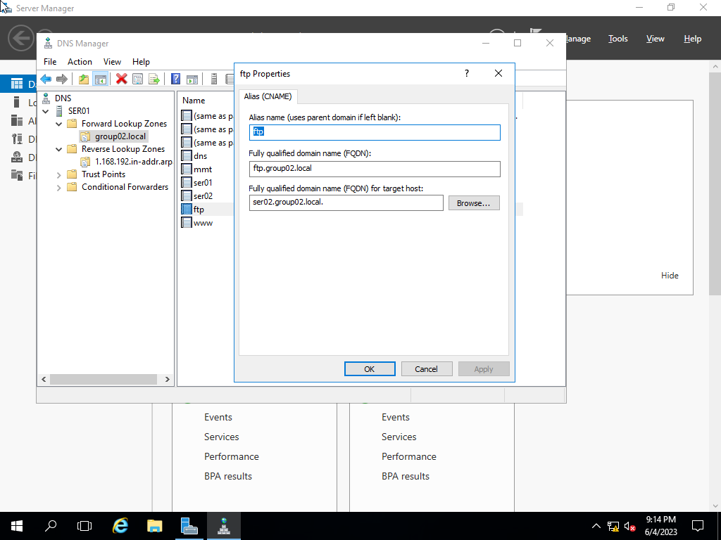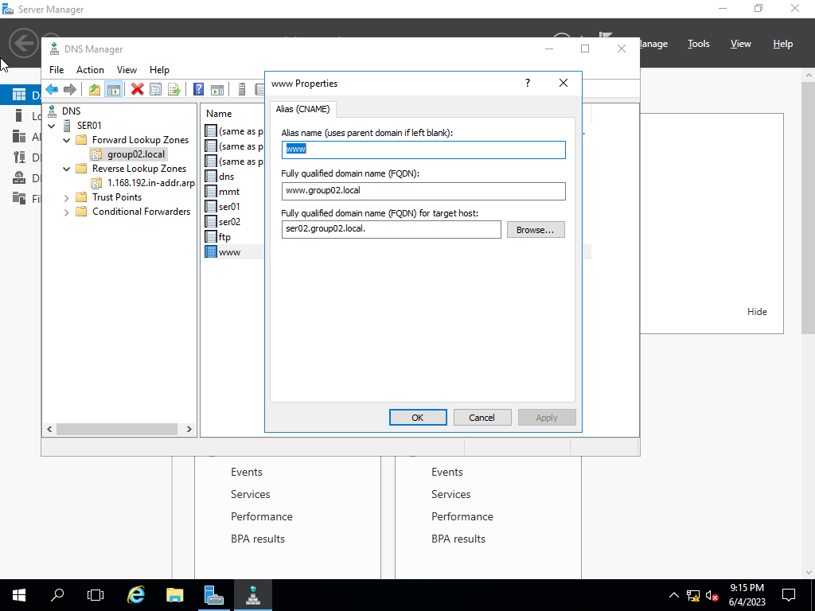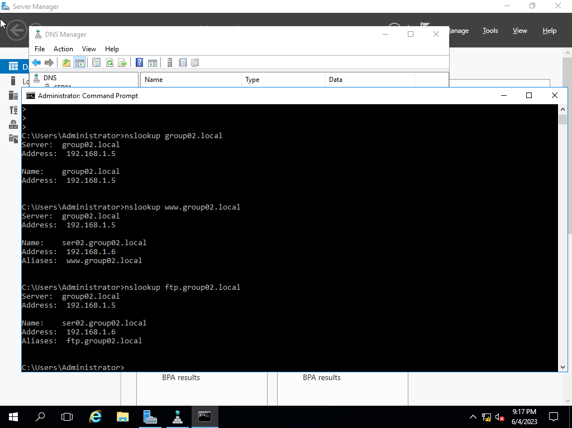

### Change the Computer Name to ser02. Assign the corresponding IP address for the network interface (refer to Table 1).

**Step1**: Start -> Control panel -> System and Security -> System.

**Step2**: Advanded system setting -> Choose tab “Computer name” -> Change.

**Step3**: Fill in the parameters like the picture below.

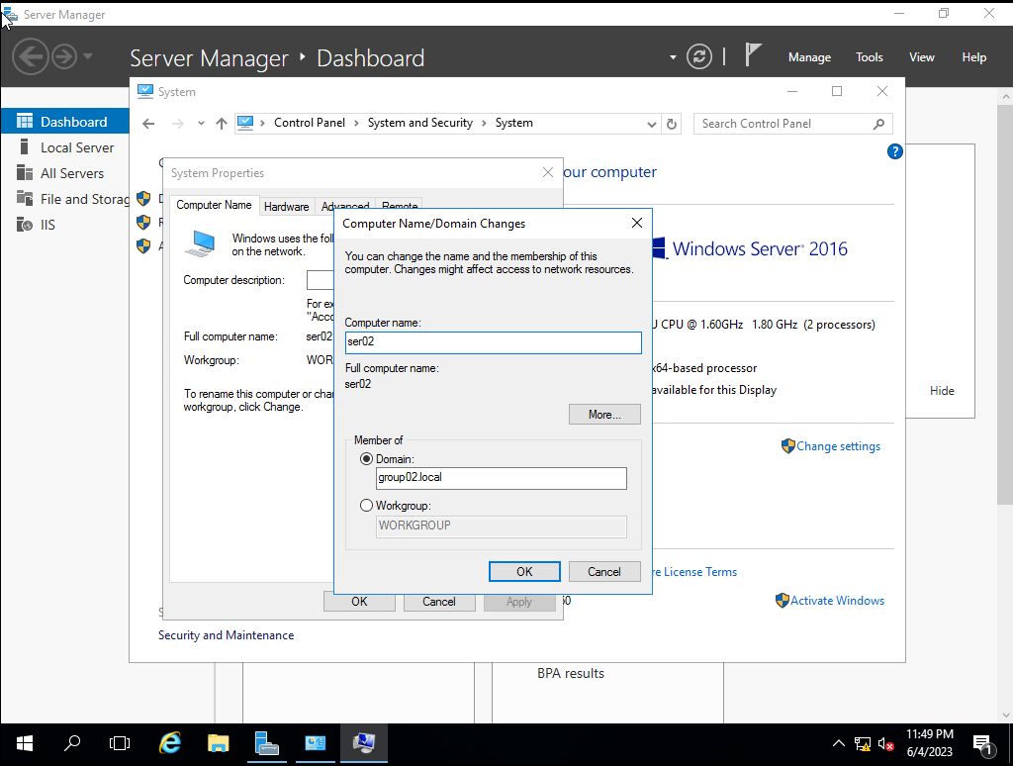

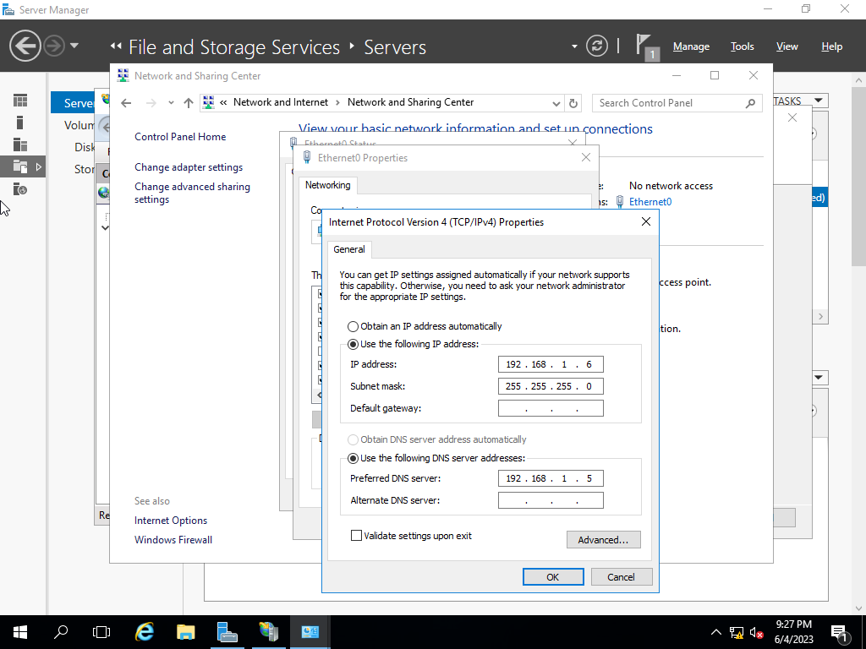

### Install the “Internet Information Service – IIS” and "FTP Server" services.

**Step1**: Server Manager -> Manage -> Add Roles and Features -> Next -> Next.

**Step2**: Choose “Web Service (IIS)” in “Server Roles” -> Add Features -> Next -> Next -> Next.

**Step3**: Choose “FTP Server” in Role Services -> Next -> Install -> Close.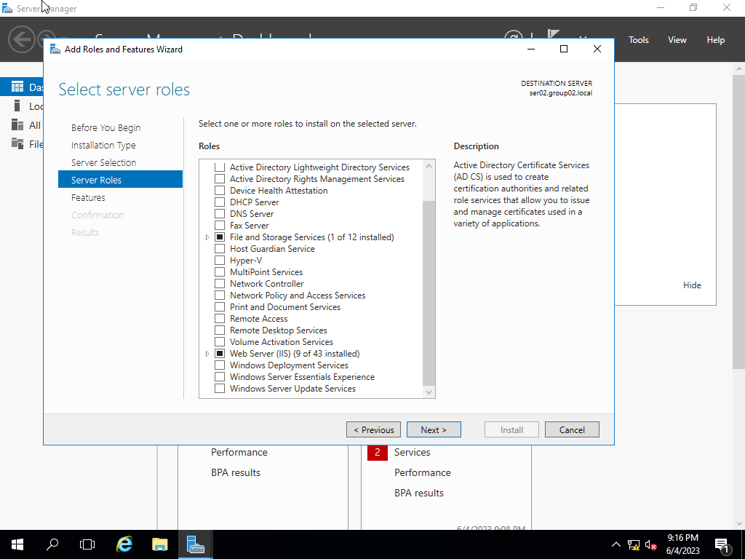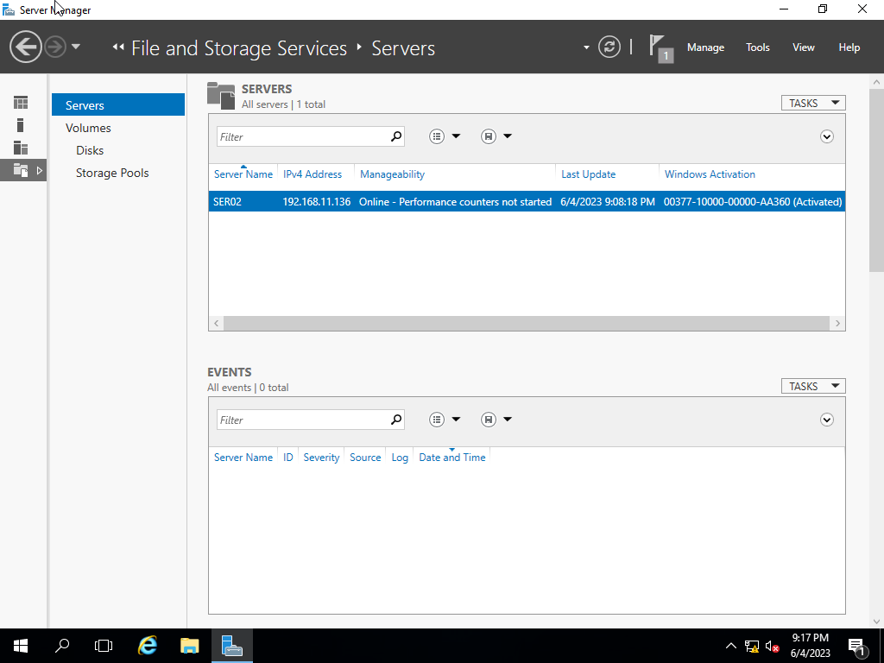

### From the IIS Manager, create an FTP site and host it on C:\FTP. It will be binding on port 21.

**Step1:** Create folder “FTP” on C:\

**Step2**: Server Manager -> Tool -> Internet Information Services (IIS) Manager.

**Step3**: Right click Site in node “SER02” -> Add FTP Site.

**Step4**: Fill in the parameters like the picture below.

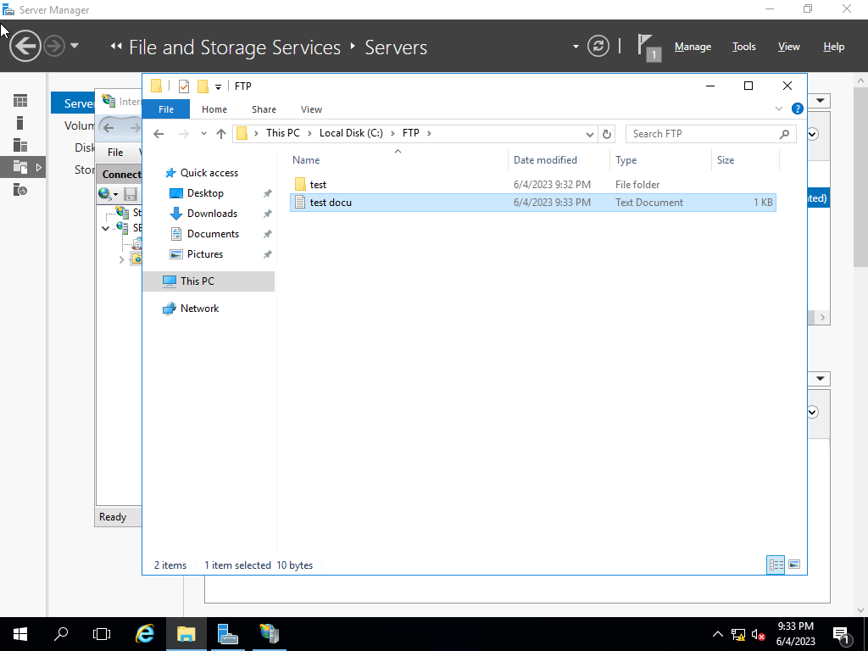

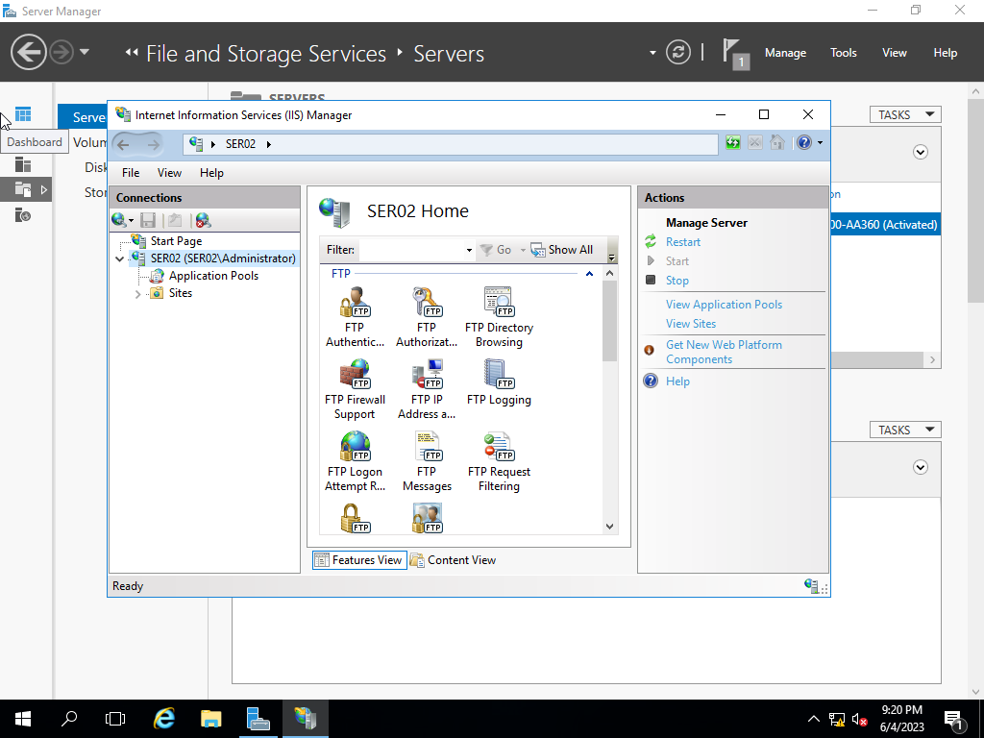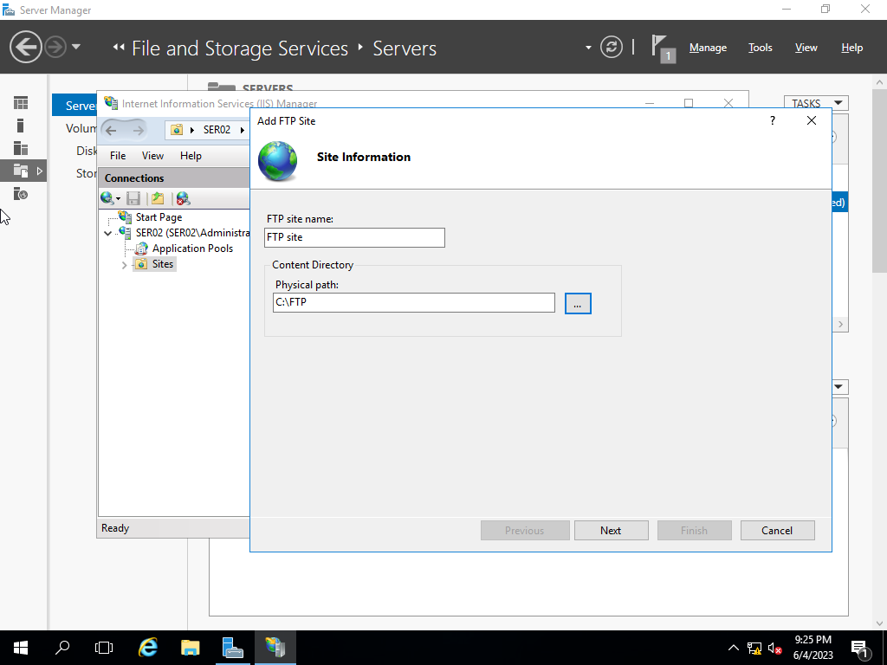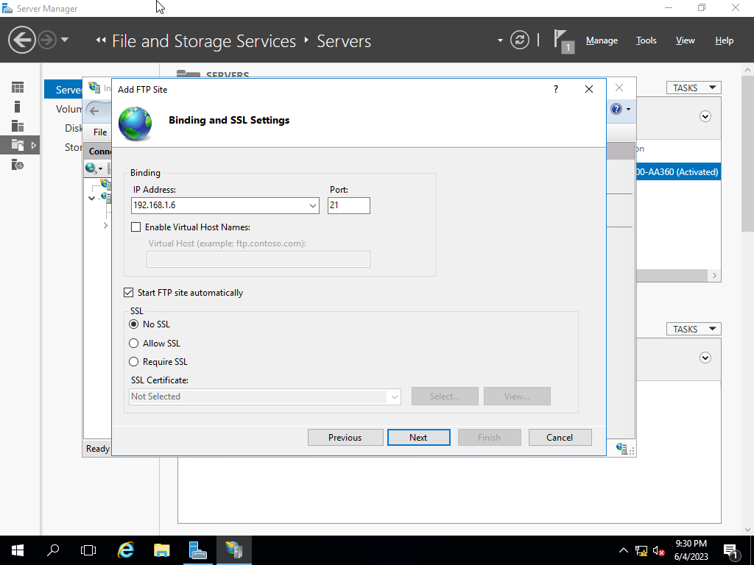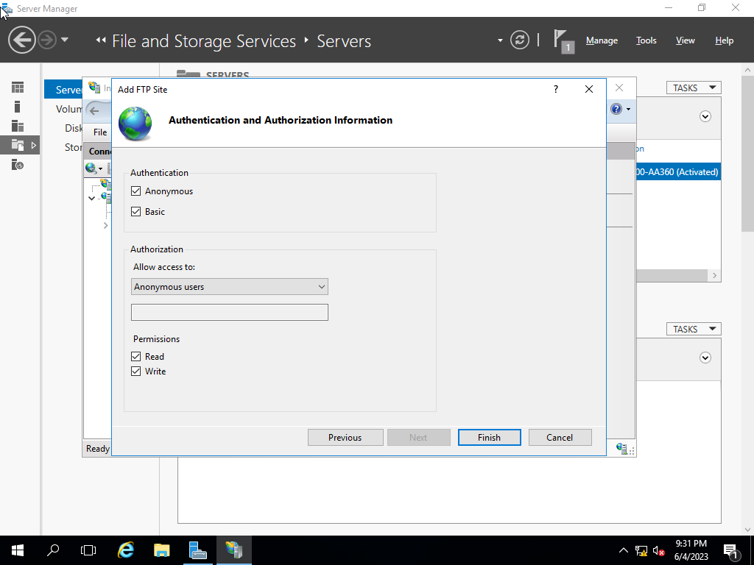

### Open web browser and access the website http://www.groupX.local and <ftp://ftp.groupX.local>.

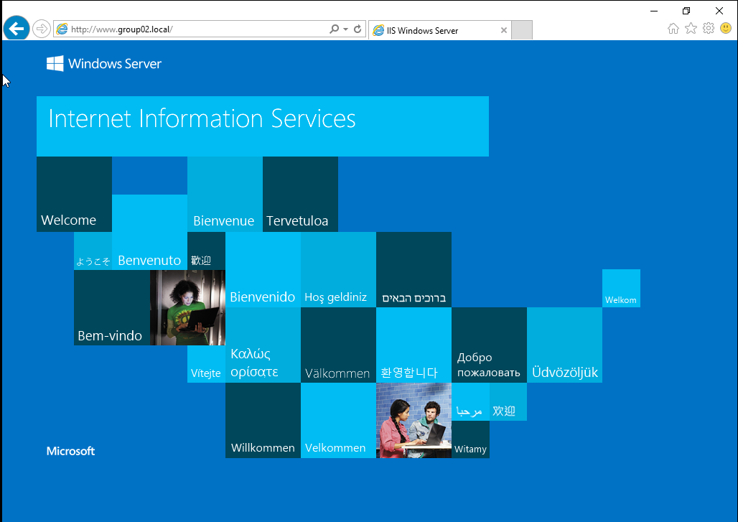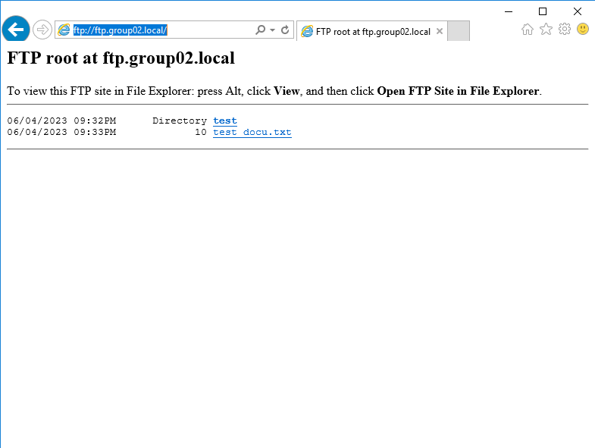

### Use an FTP Client application (e.g., FileZilla, WinSCP,...) to upload and manage resources on the FTP server through FTP protocol.

**Step1**: Set host -> OK

**Step2**: Choose folder in “C:/FTP” in “Local site” area

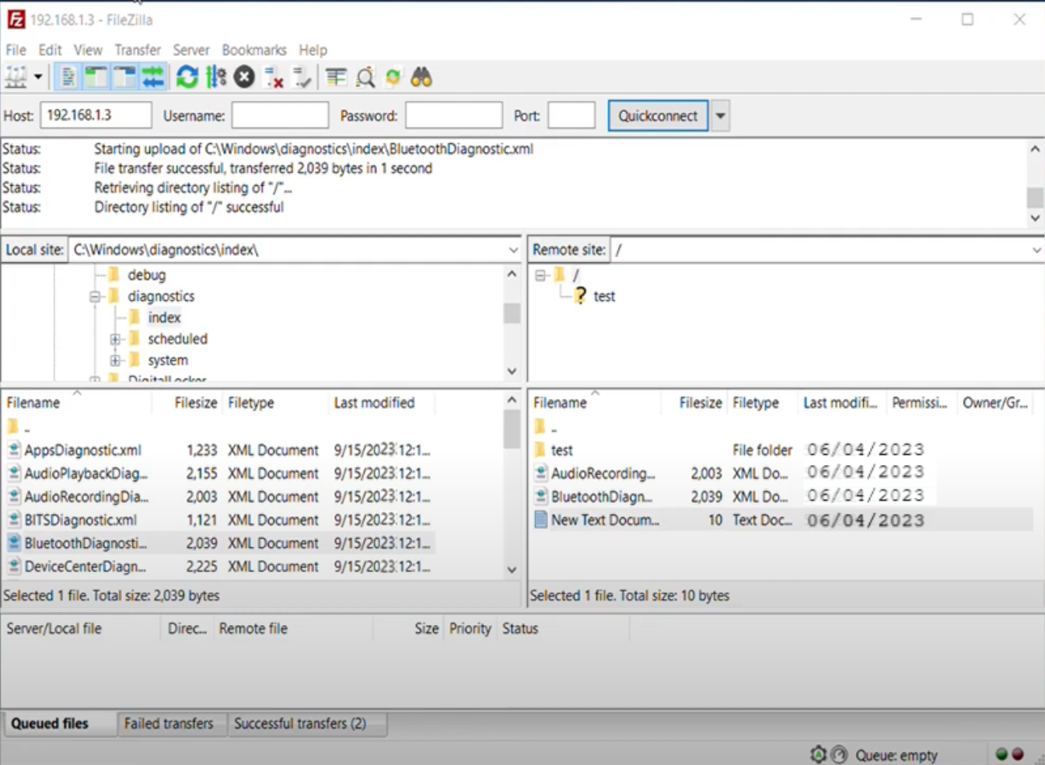

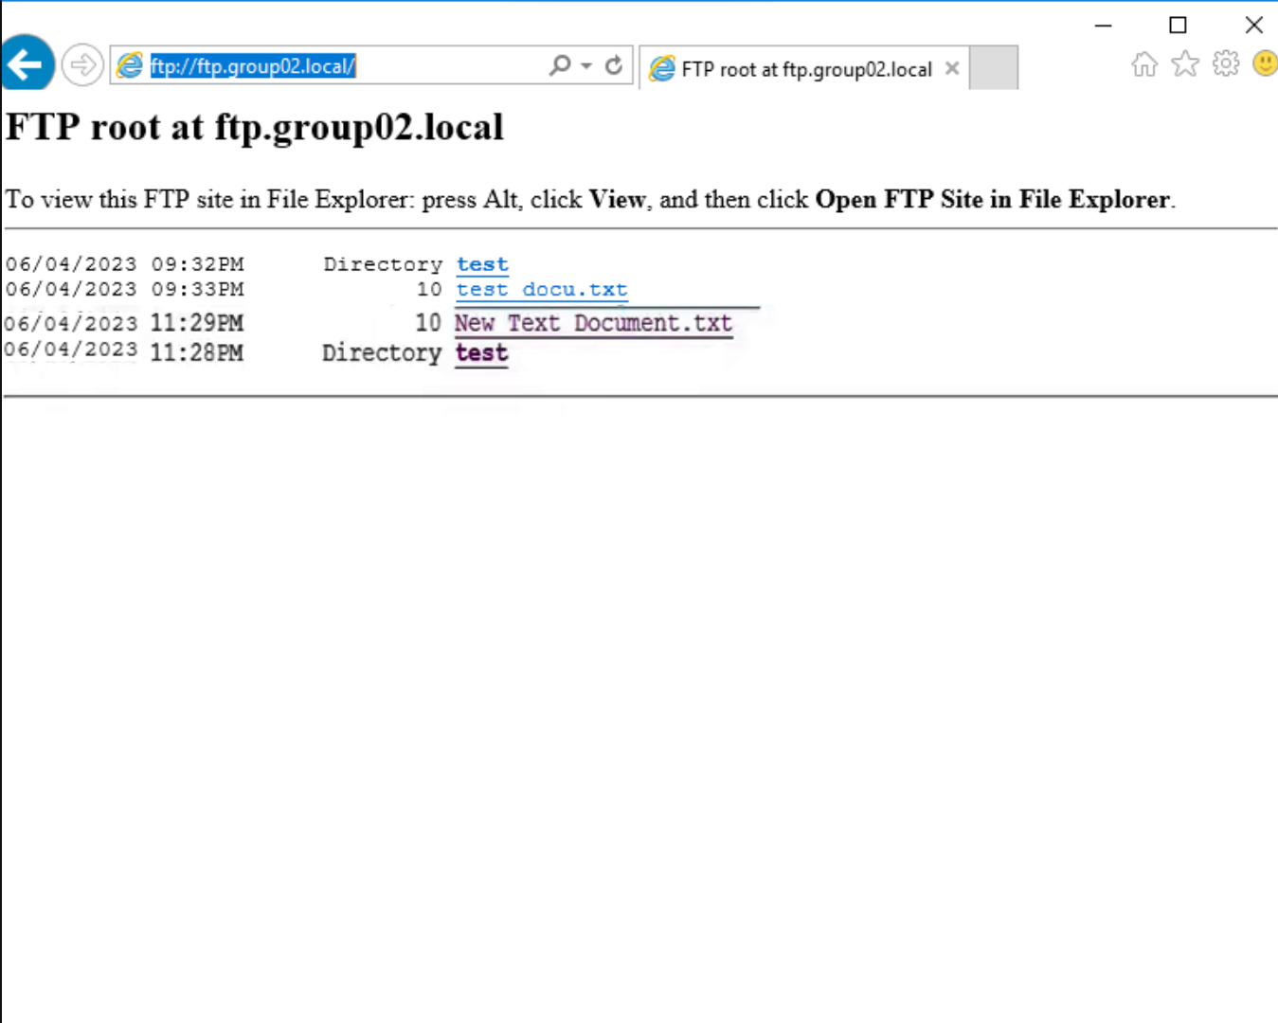

## Mail Server

### Install the Microsoft Mail Exchange service. The Domain name for email is groupX.local (X is the group ID).

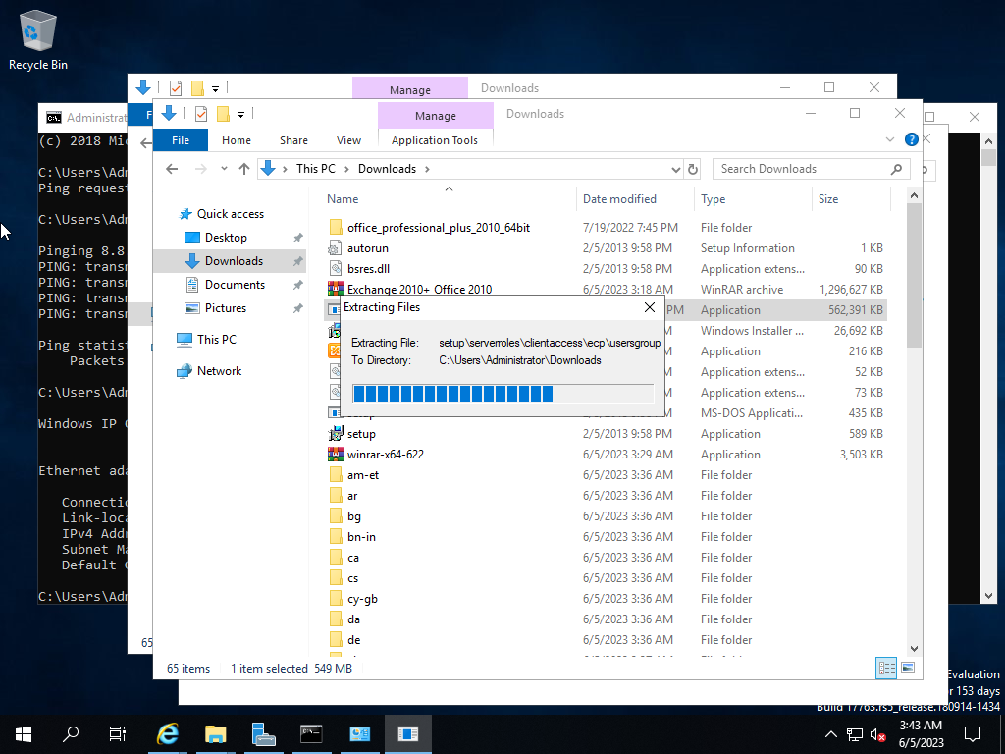

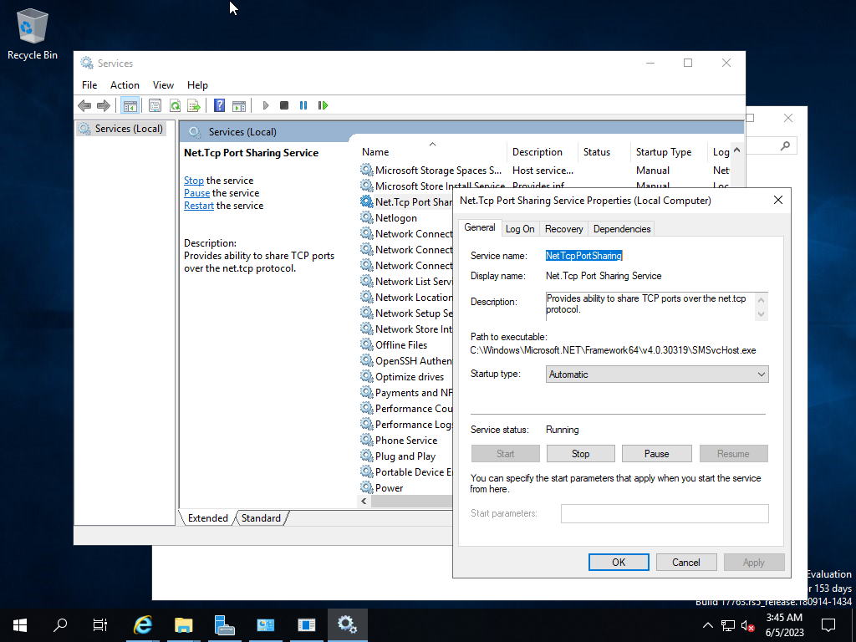

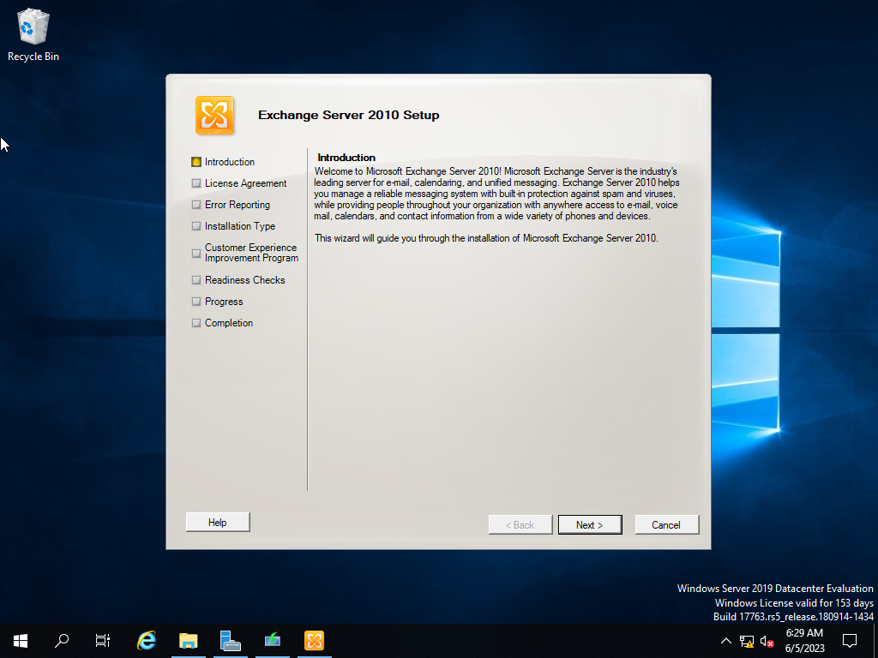

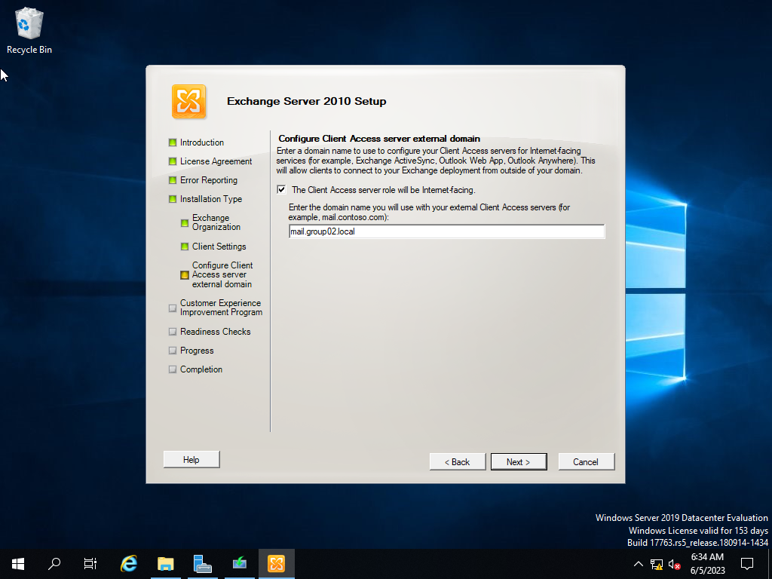

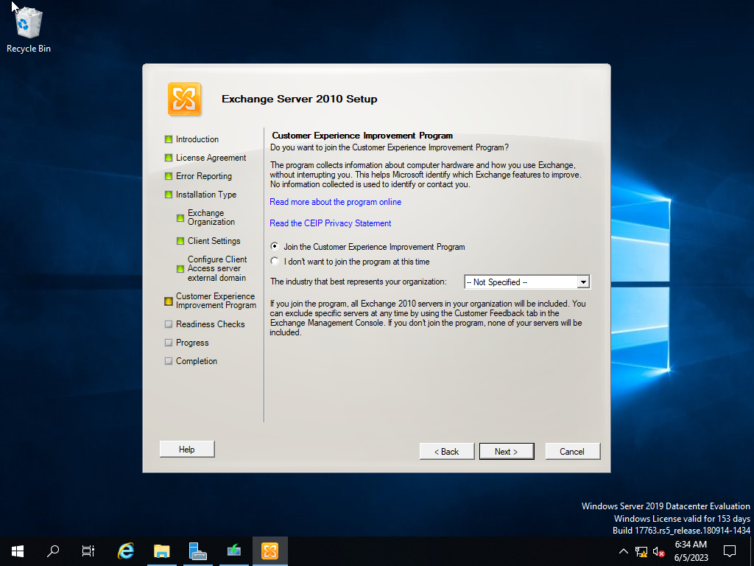

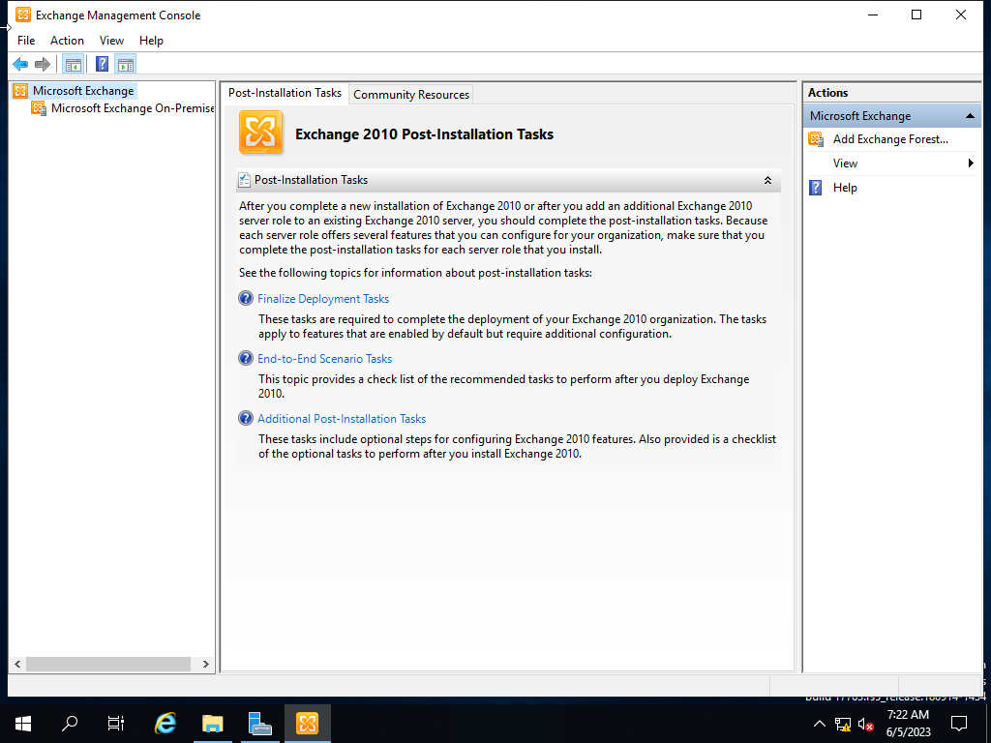

Join Domain is similar to previous lab.

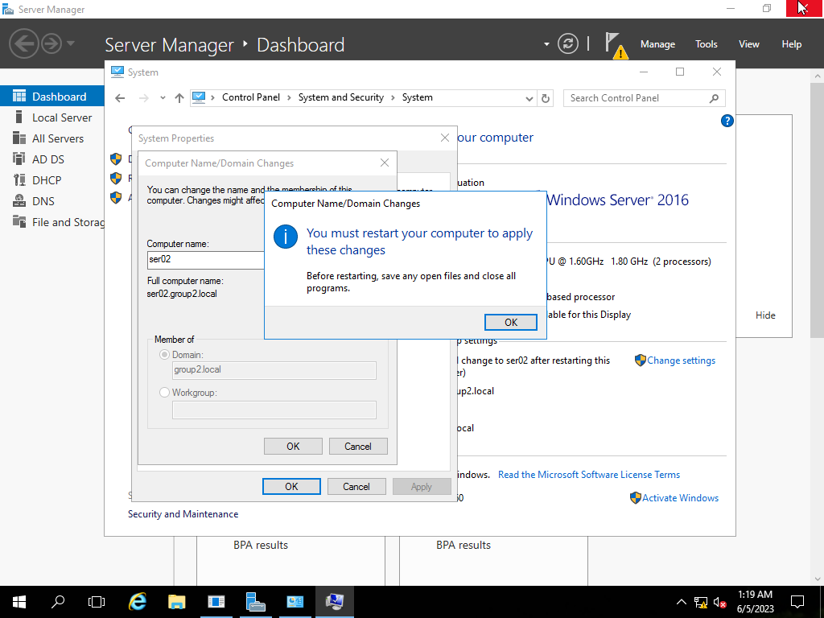

### Create the appropriate DNS records on Server 1 to send and receive emails; and access the management portal through domain name instead of IP address.

**Step1**: Server Manager -> Tool -> DNS.

**Step2**: In node “Forward lookup Zones” choose “group02.local”.

**Step3**: Right click -> New mail Exchanger -> Fill in the parameters like the picture below.

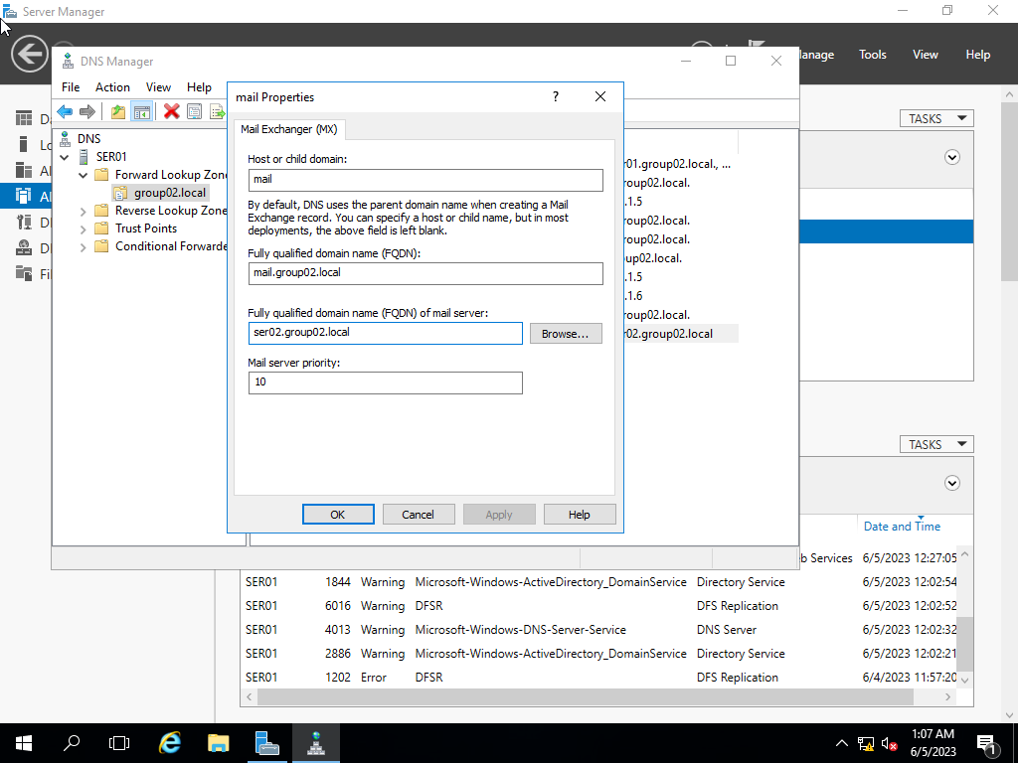

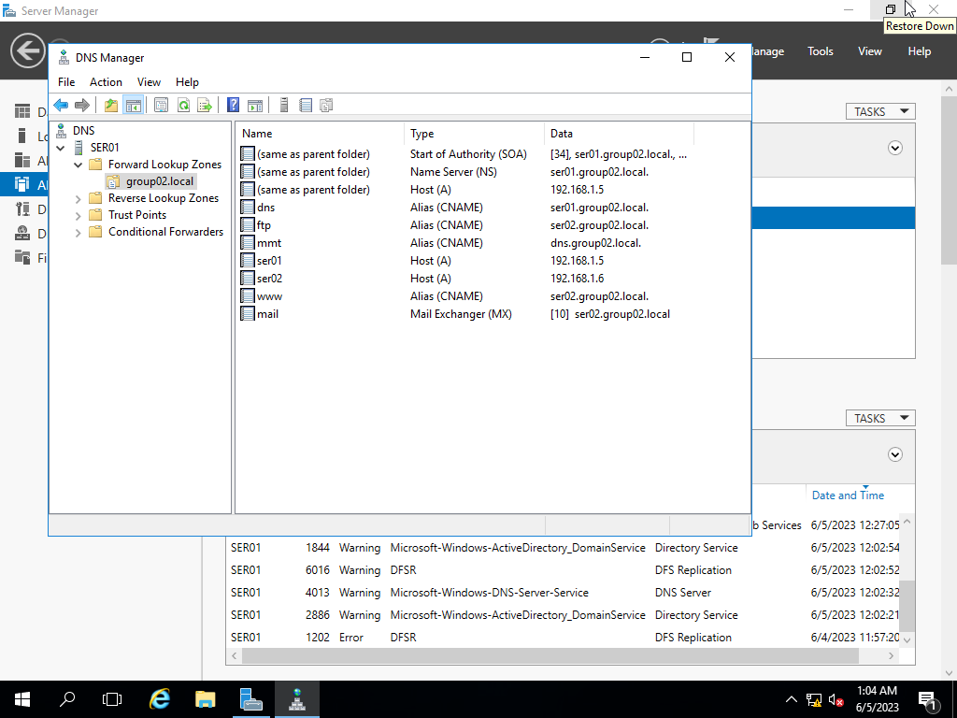

### Create new email accounts report@groupX.local, [student1@groupX.local](mailto:student1@groupX.local), and student2@groupX.local . Try sending a new email from student1 to student2.

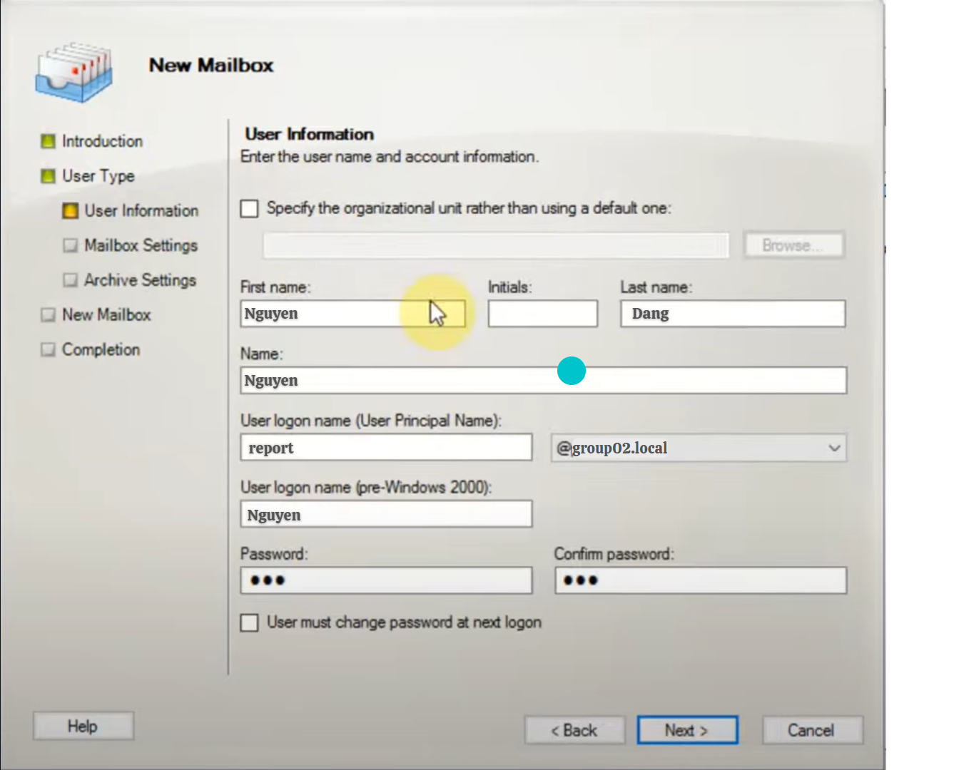

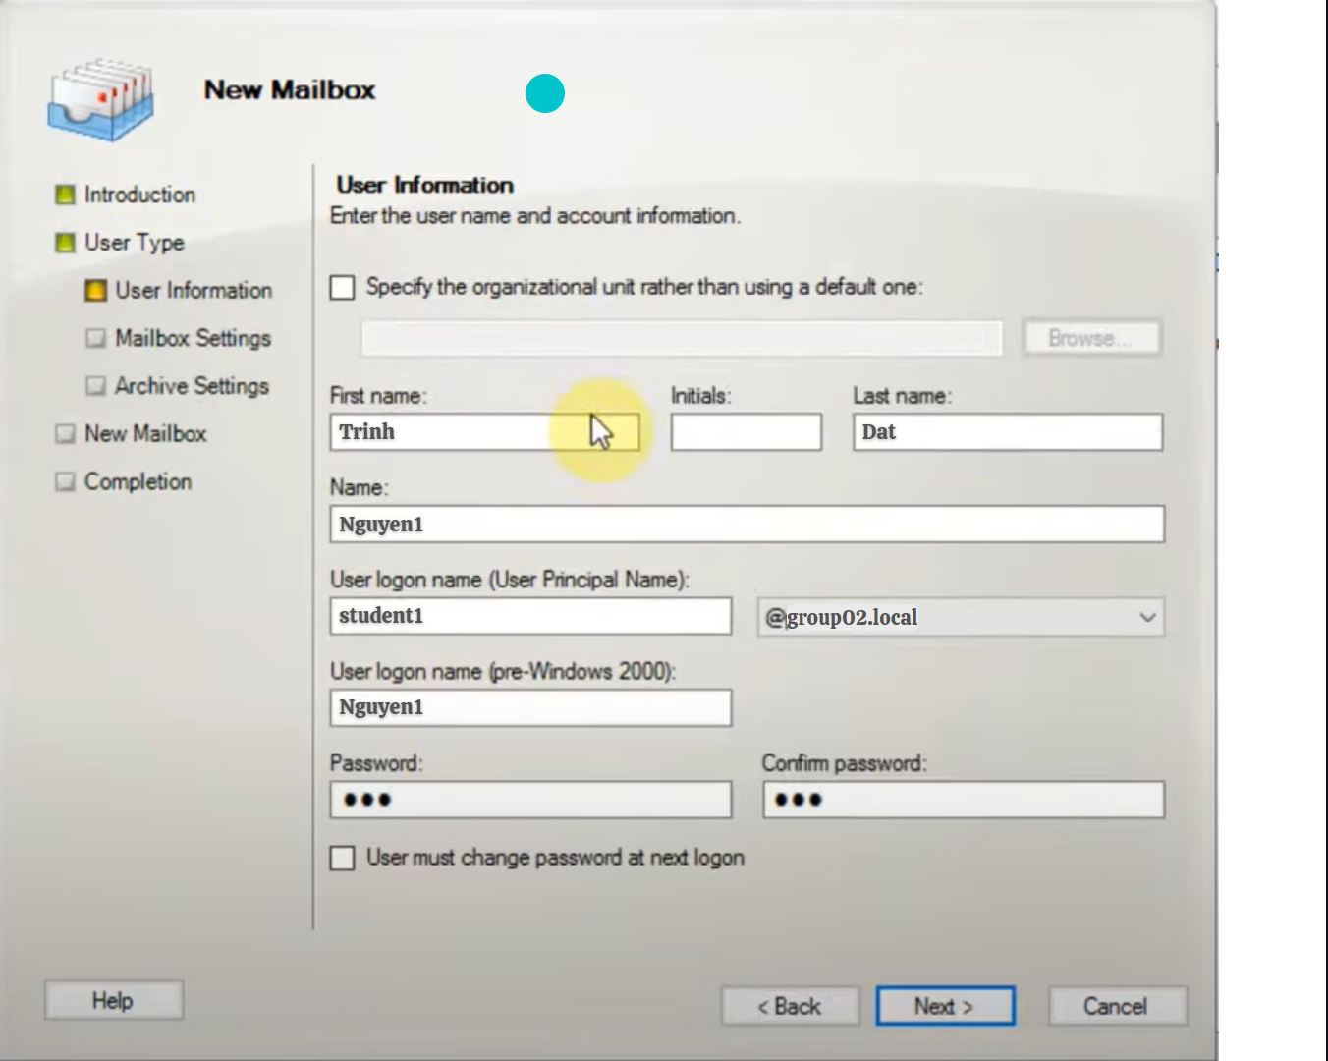

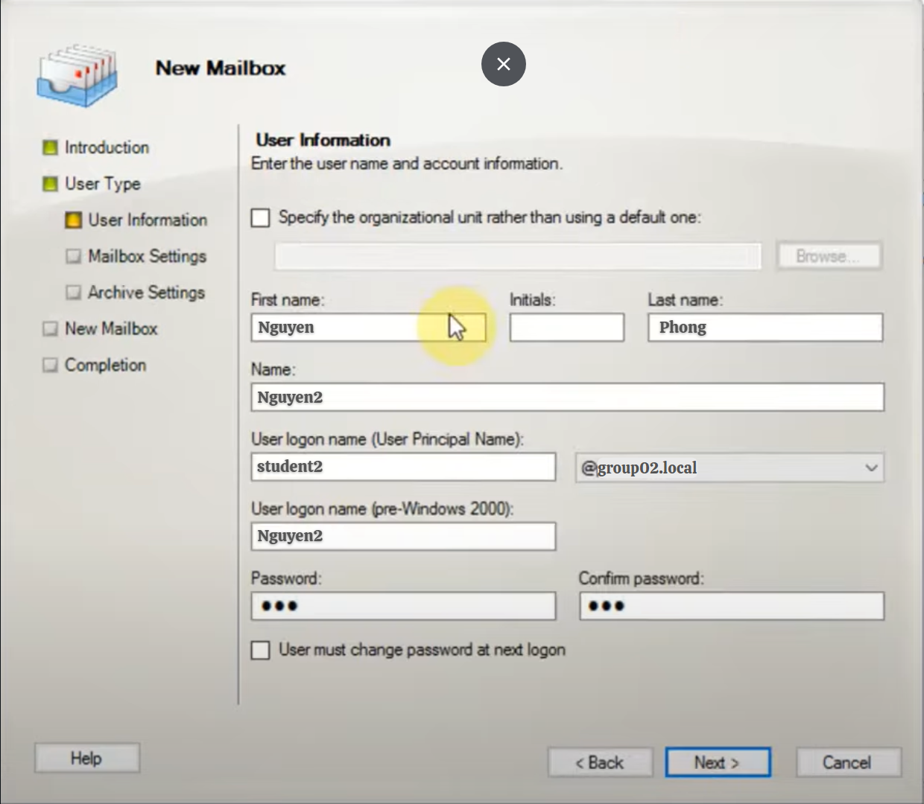

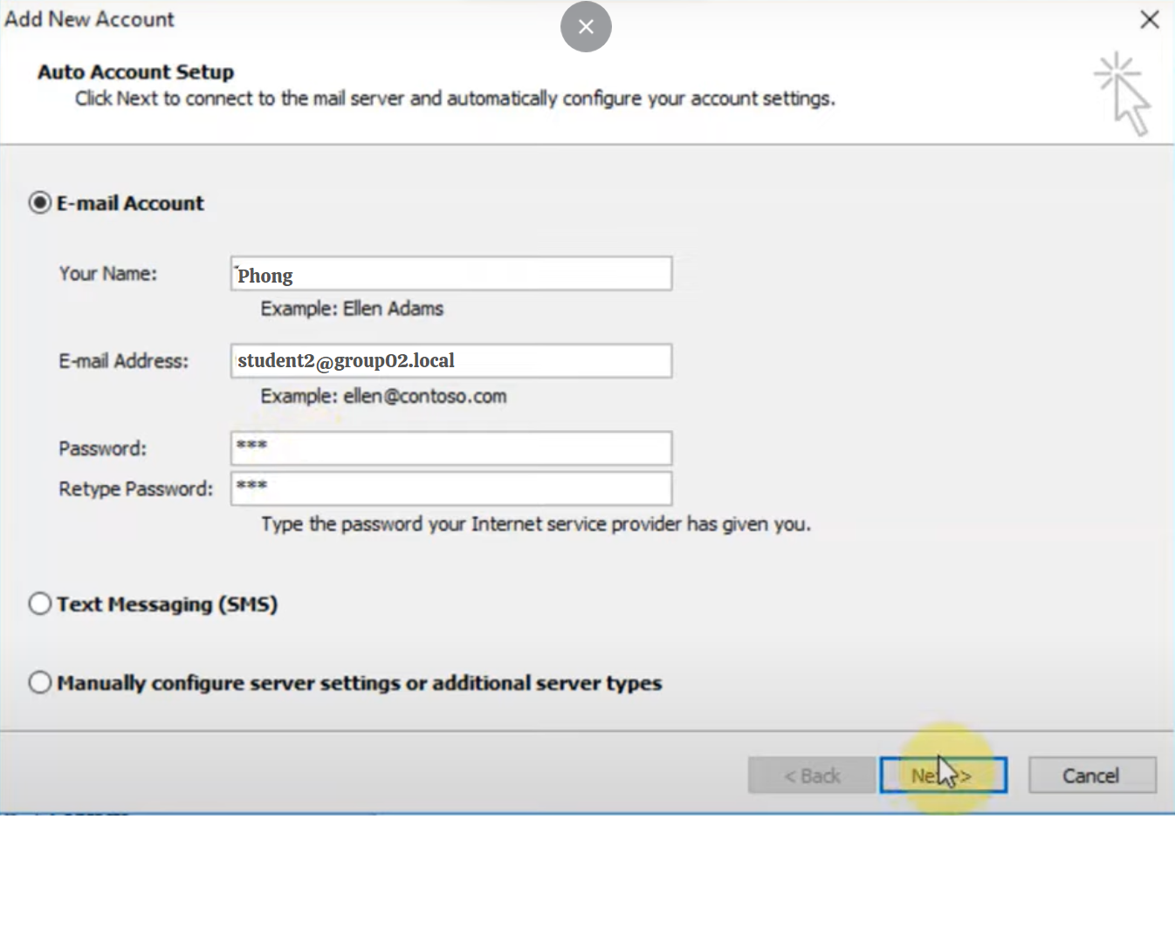

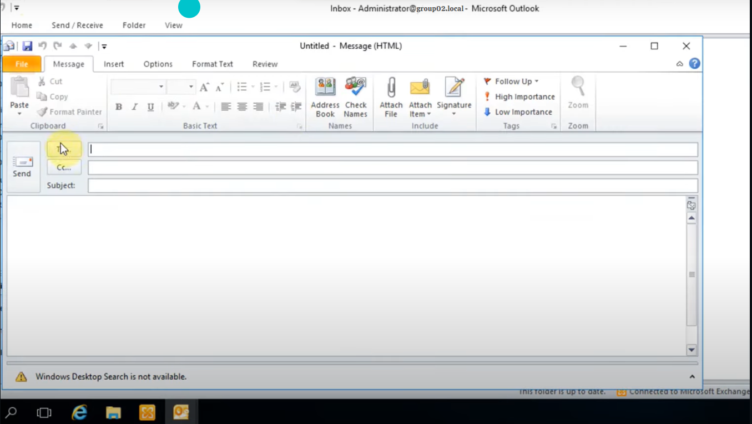

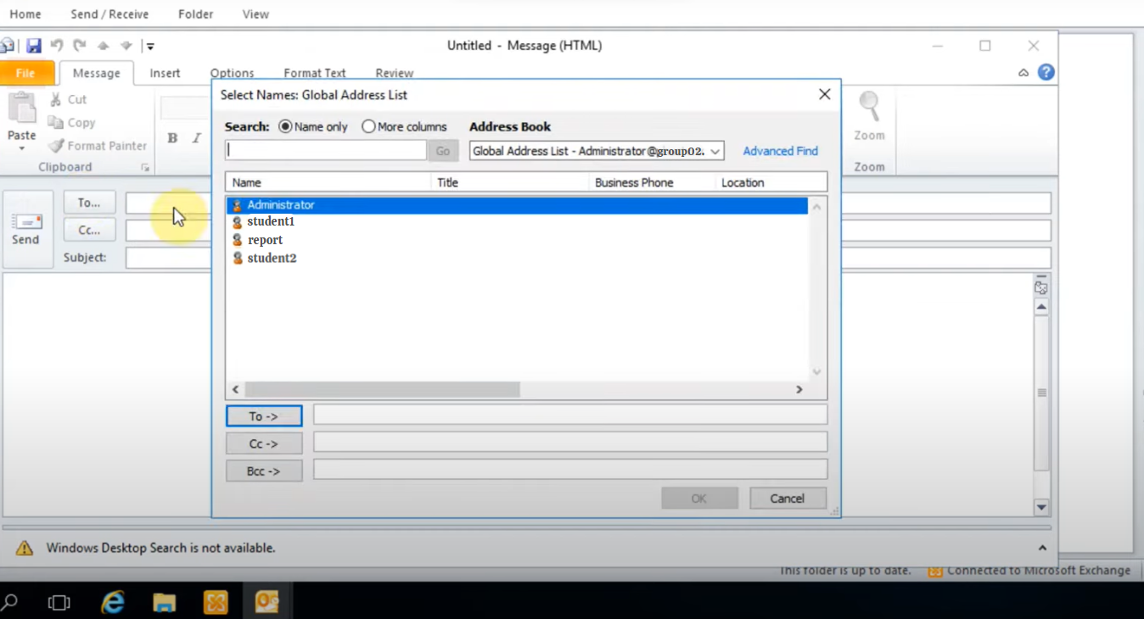

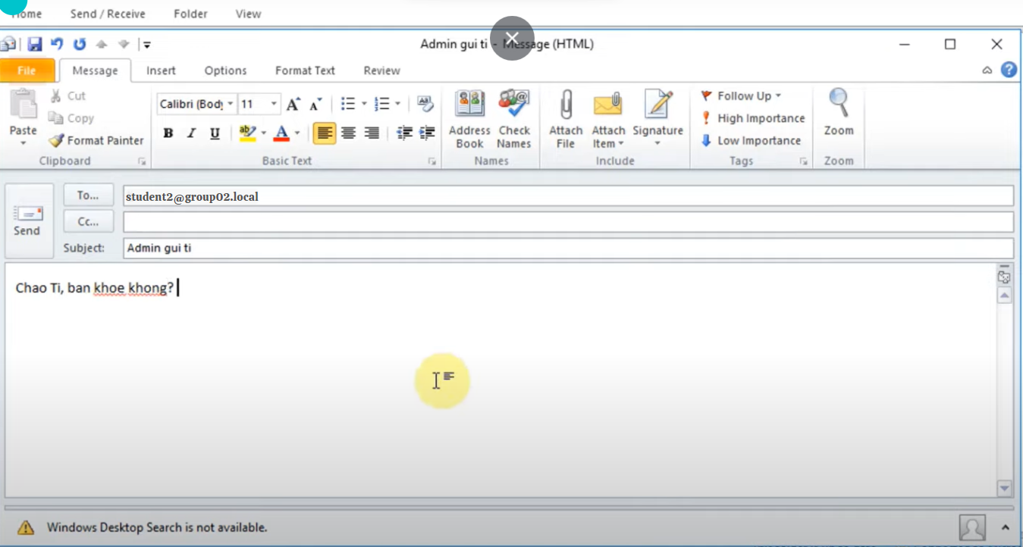

### Use a Mail Client (e.g., MS Outlook, Thunderbird) to access and manage your mailbox, as well as send or receive emails.

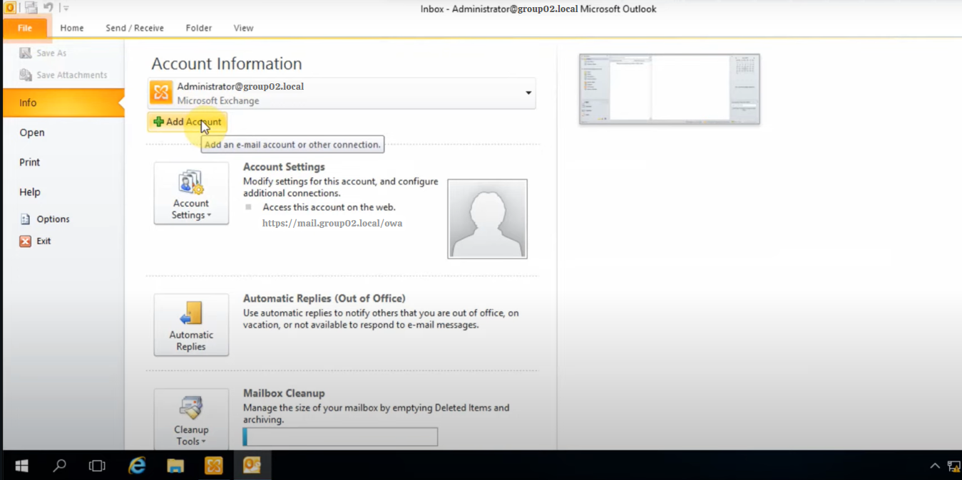

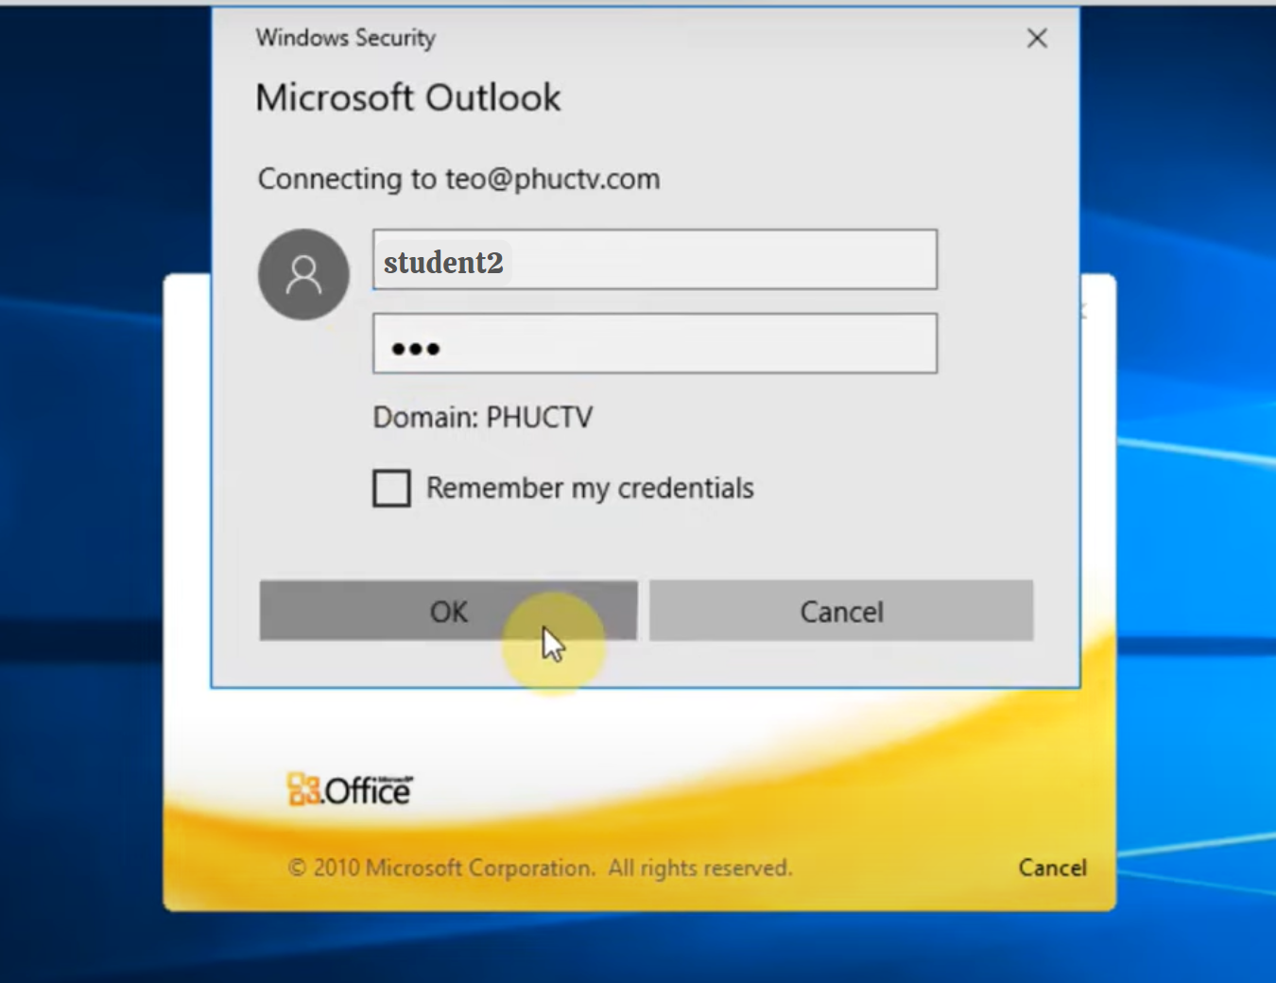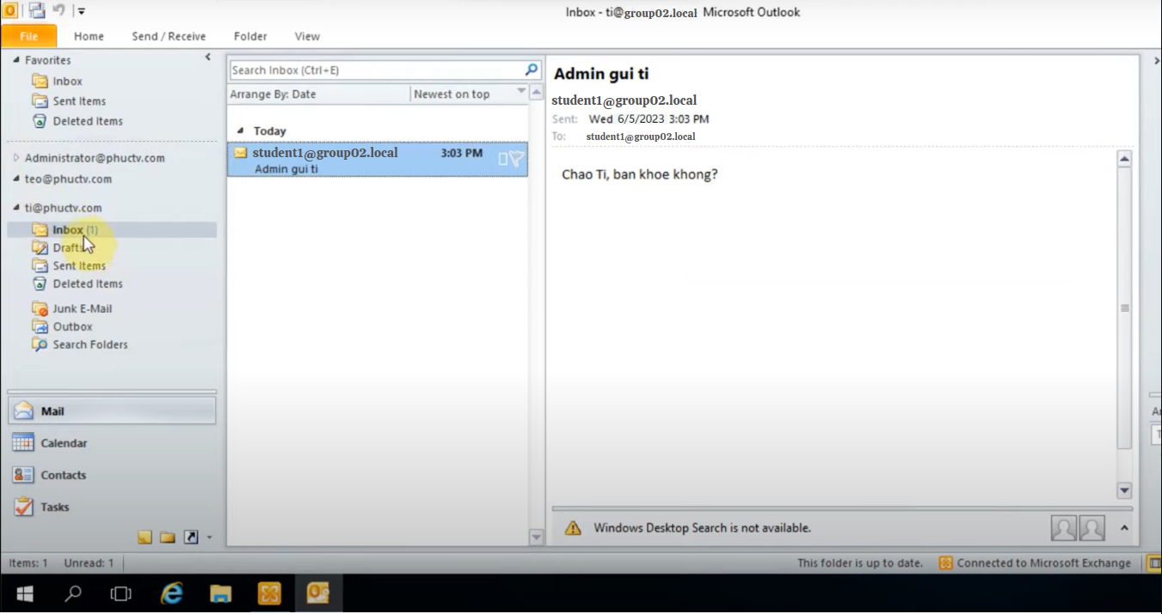

### Design and implement policies on Mail Server to:

Limit the size of attachment files to 1MB.

Automatically forward email to report@groupX.local if it contains the encrypted .ZIP file.

Automatically drop emails that contains special keyworks (e.g.,"username", "password",...).

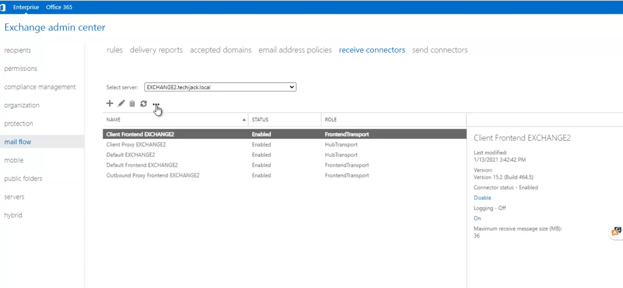

# References

<https://www.cloudflare.com/learning/dns/what-is-dns/>

<https://learn.microsoft.com/en-us/windows-server/networking/technologies/dhcp/dhcp-top>

<https://www.javatpoint.com/computer-network-ftp>